Tour ID: 229951  
Tour Name: Blue Lagoon & Reykjavík Sightseeing - (comfort ticket to BL inluded) - Private Day Tour

Tour destinations: ['Reykjavik', 'Blue Lagoon']

Tour destinations images:

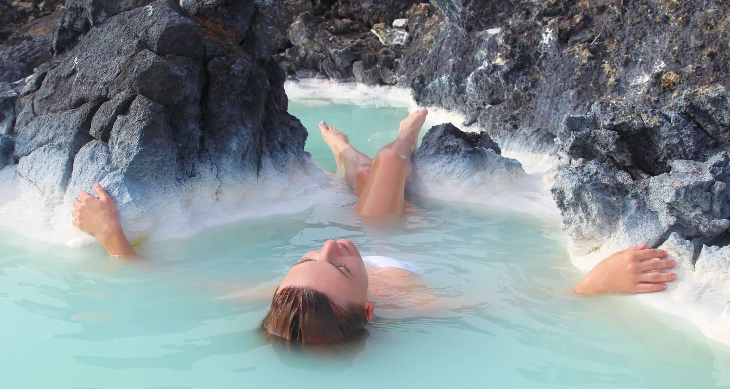

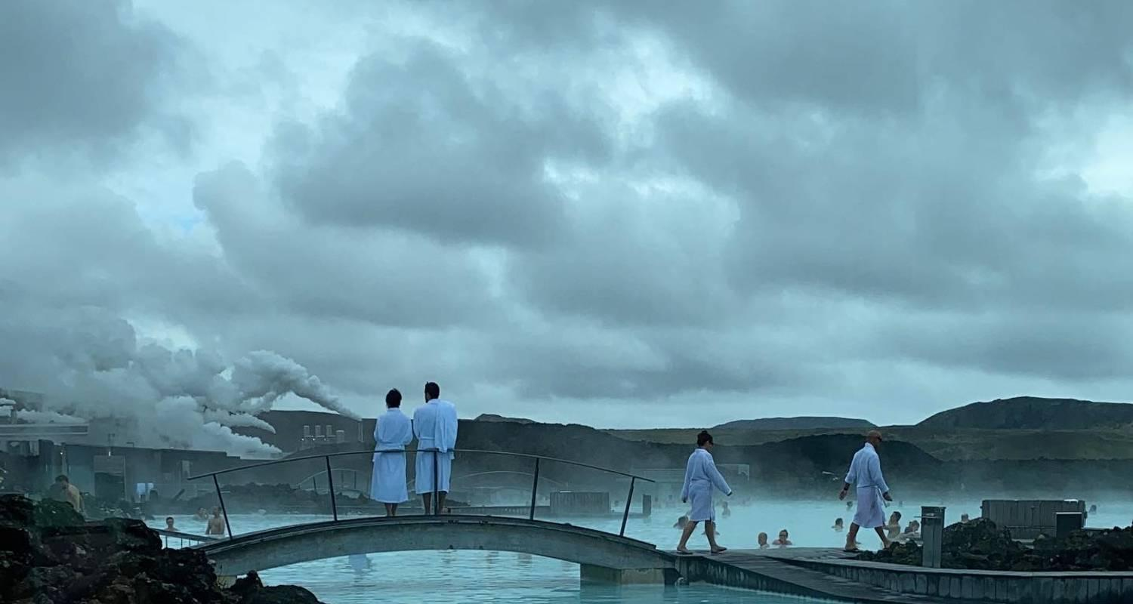

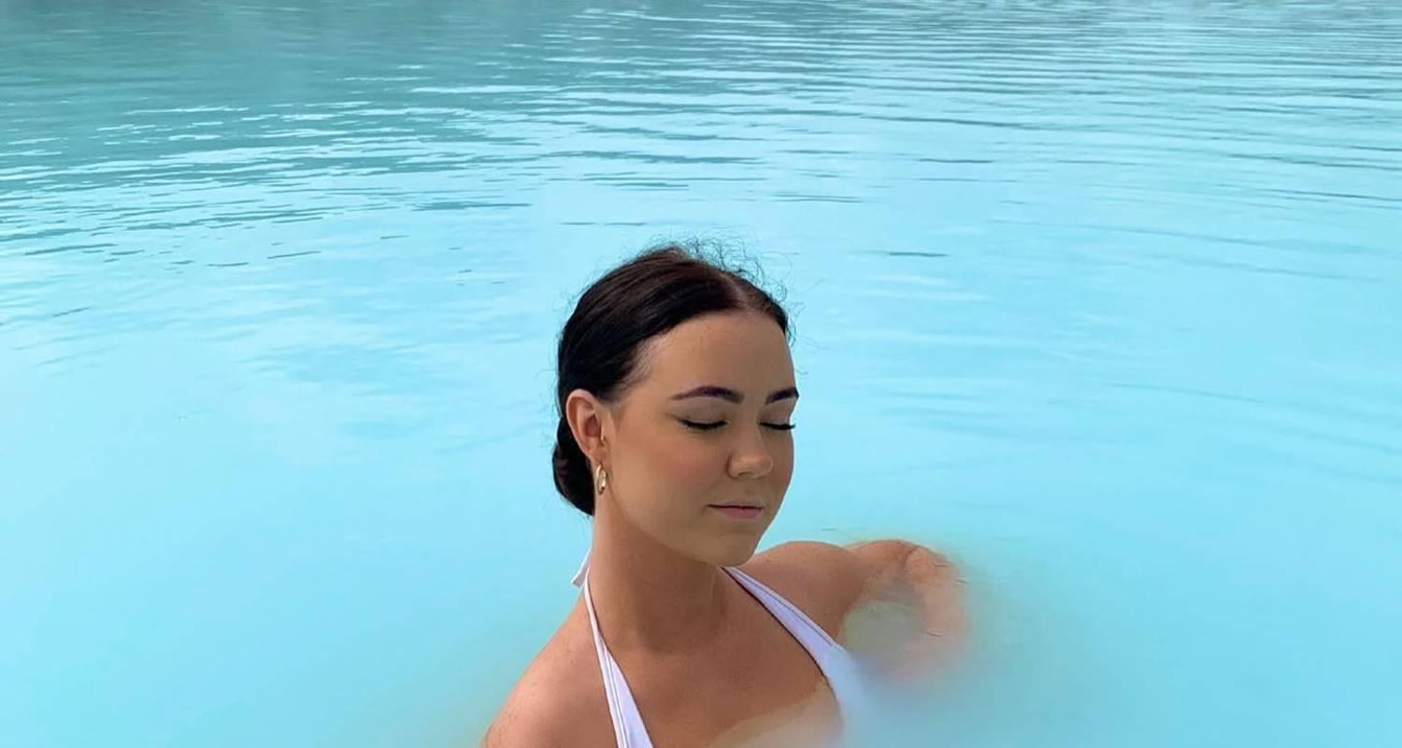

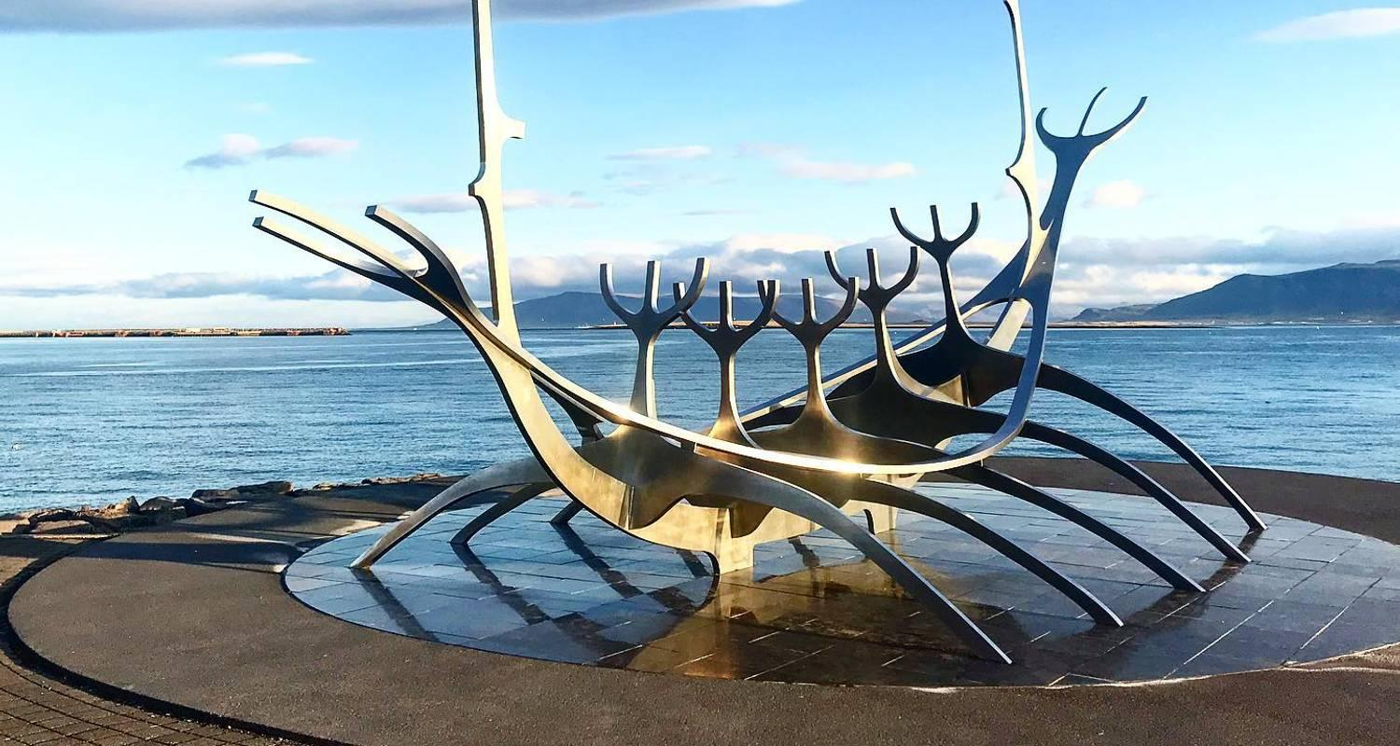

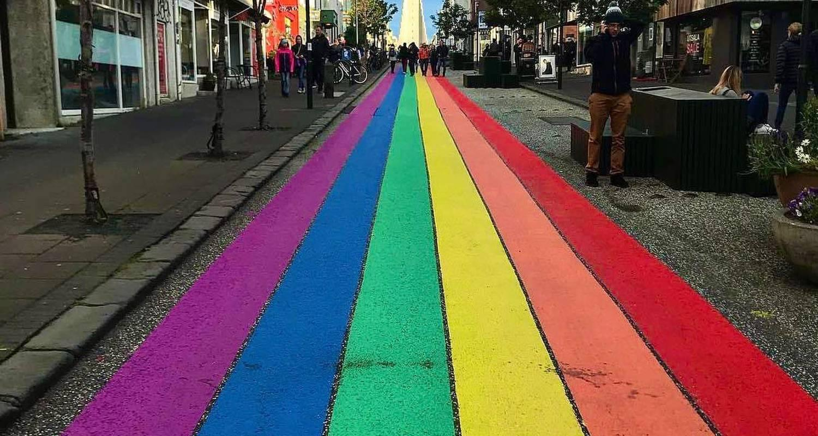

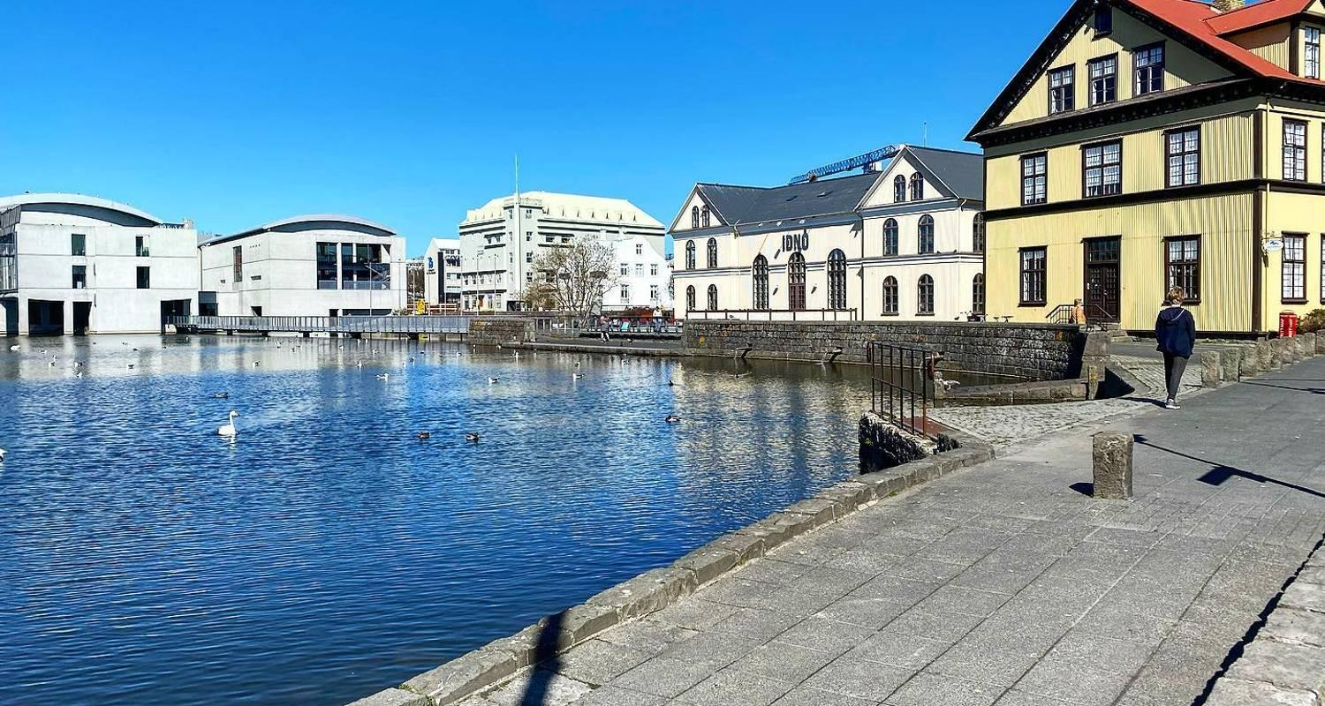

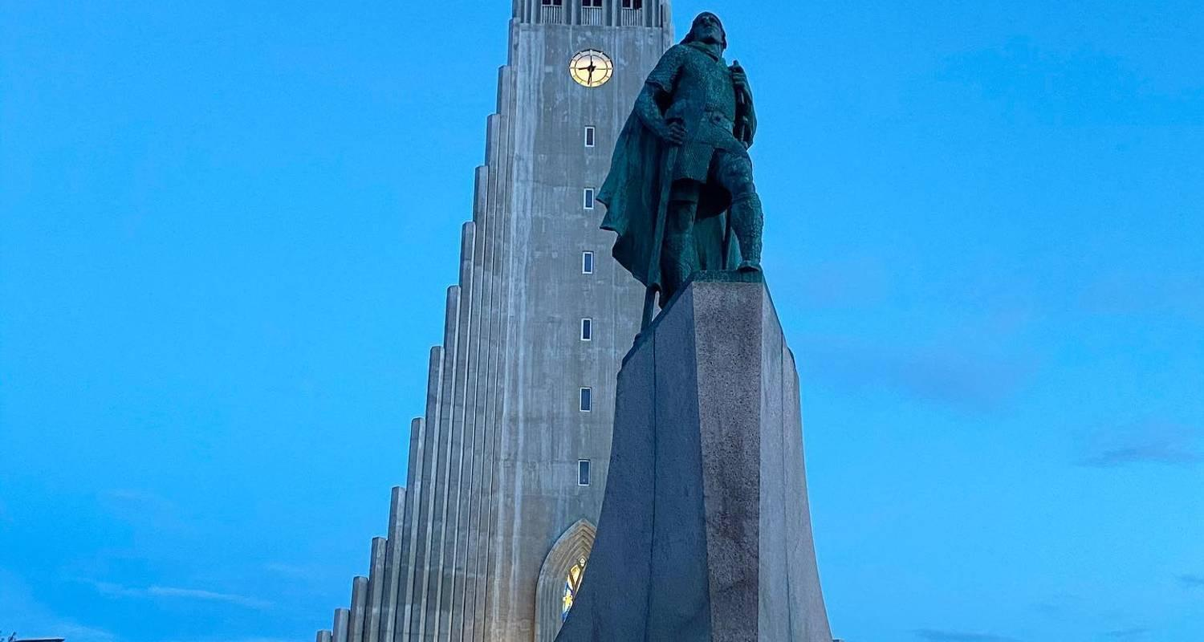

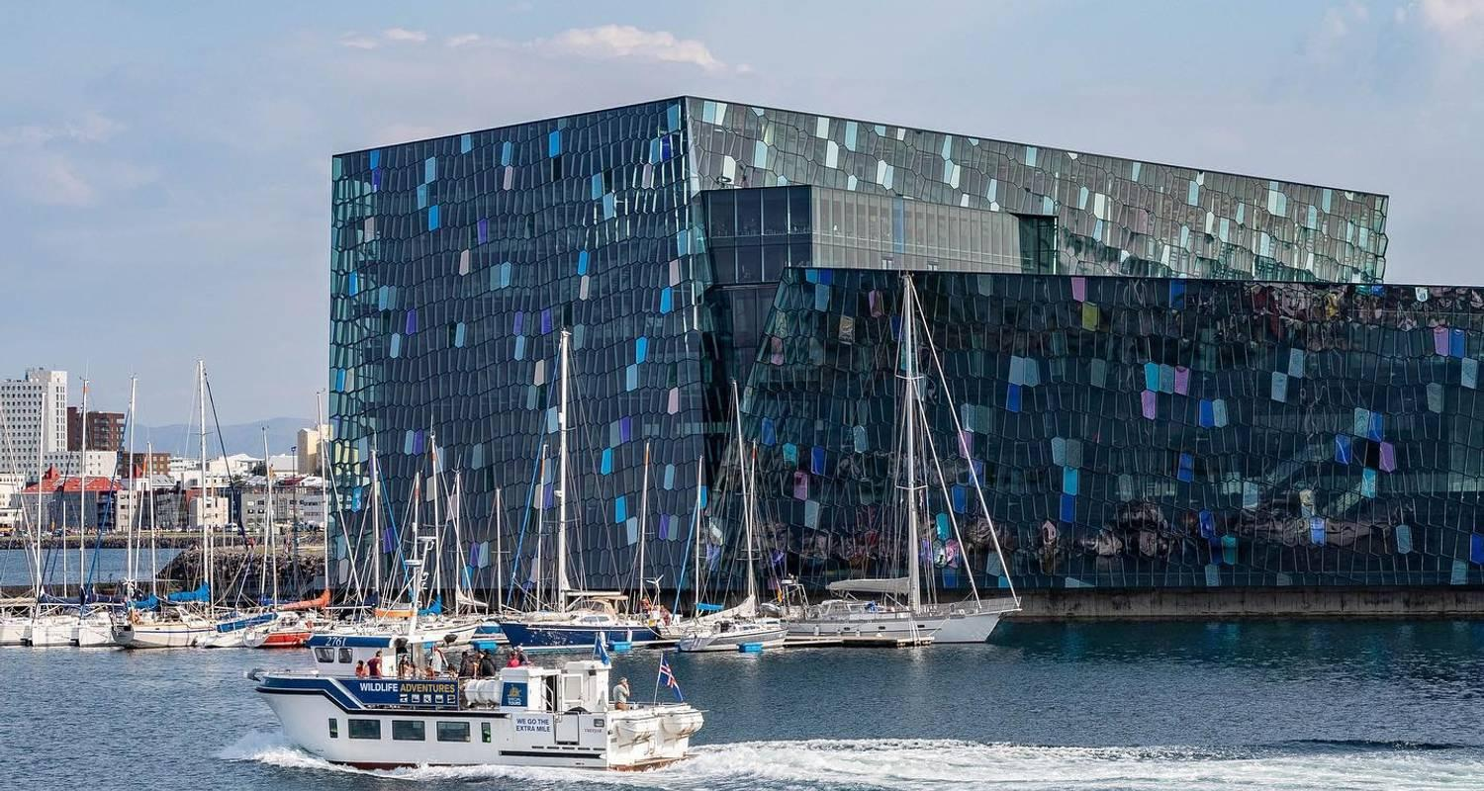

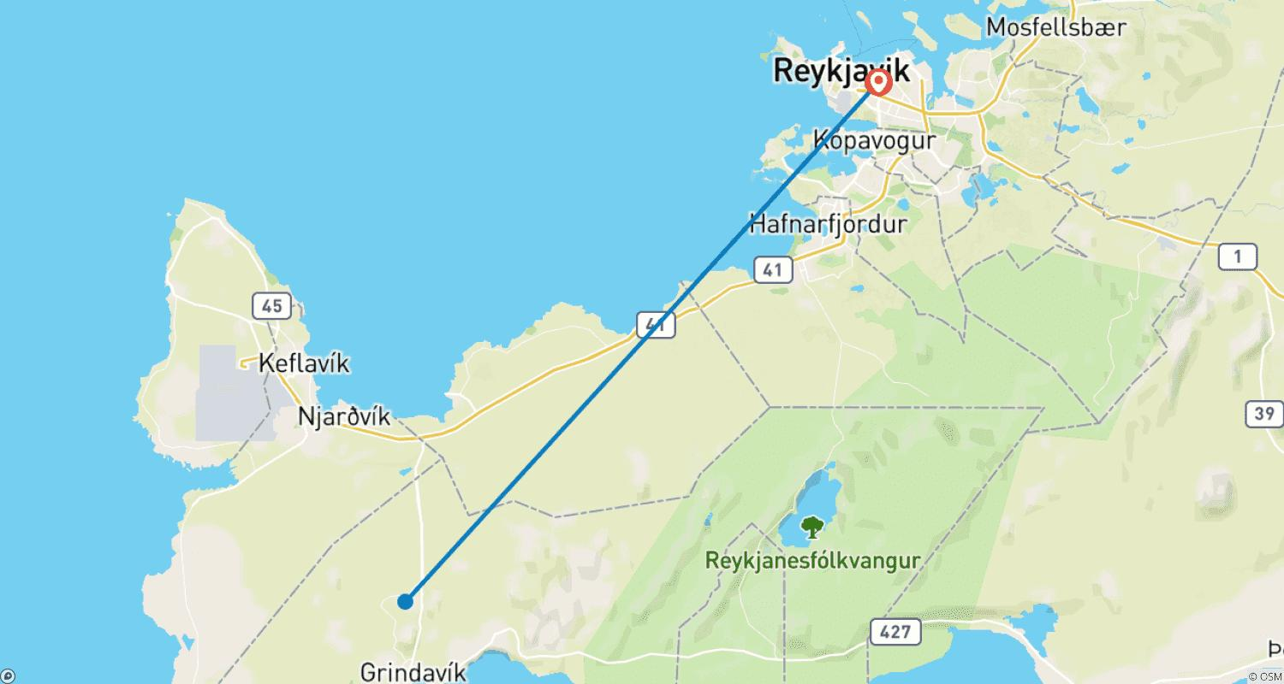

Tour ID: 230098  
Tour Name: Greenland Disko Bay Discovered - 8 Days (from Reykjavik to Kangerlussuaq)

Tour destinations: ['Reykjavik', 'Kangerlussuaq', 'Sisimiut', 'Qeqertarsuaq', 'Uummannaq', 'Ilulissat', 'Sarfannguit']

Tour destinations images:

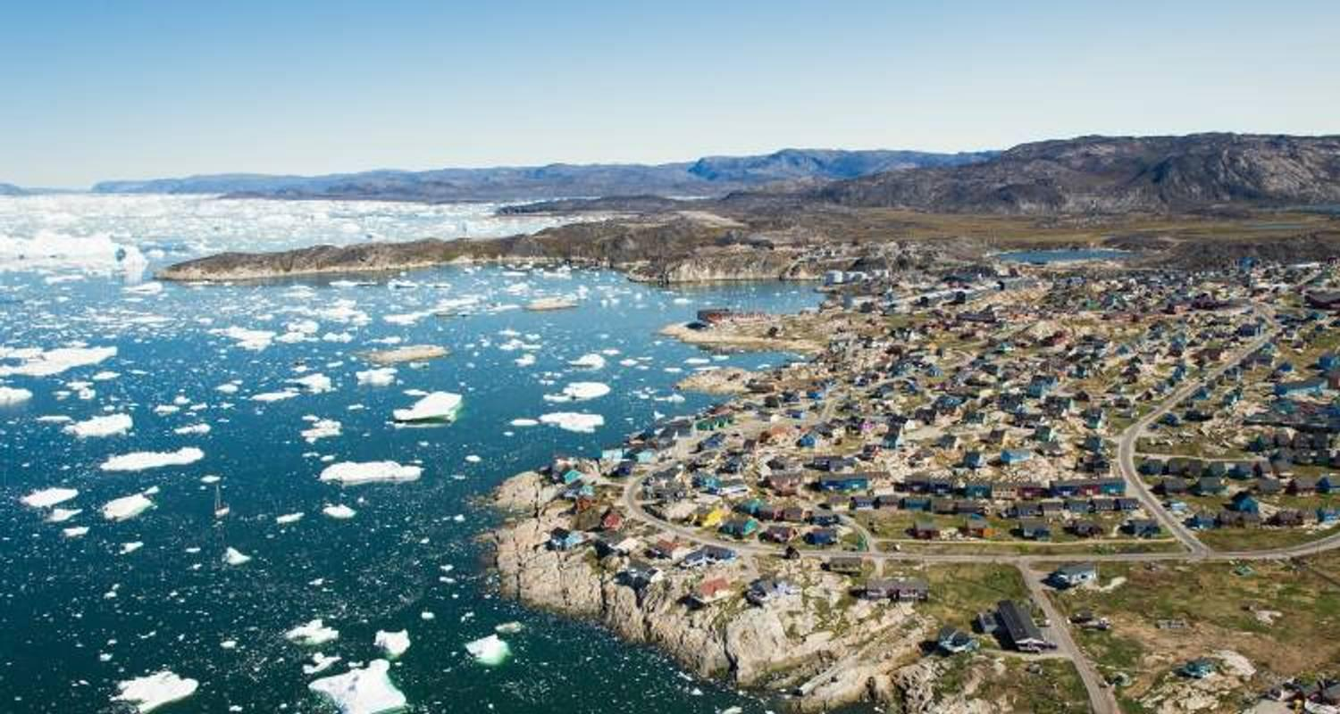

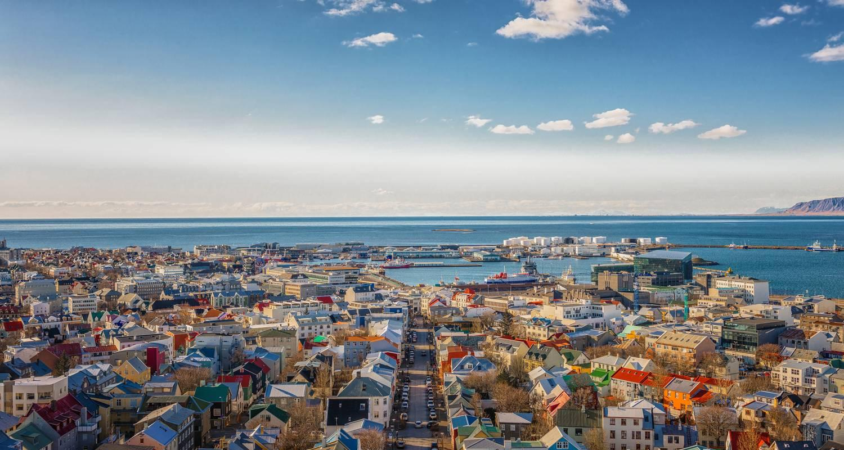

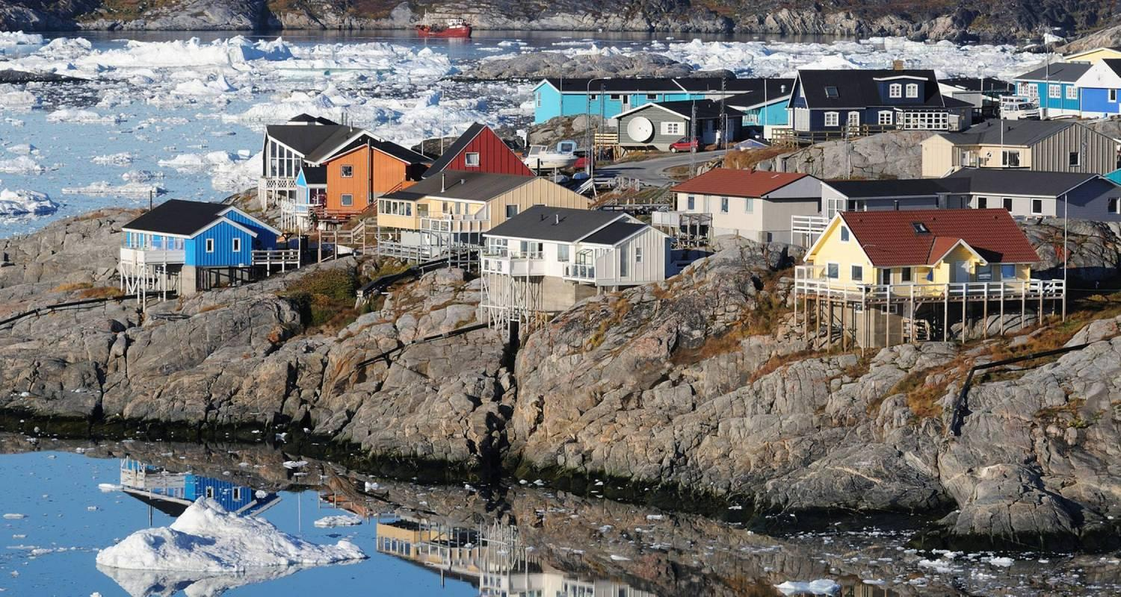

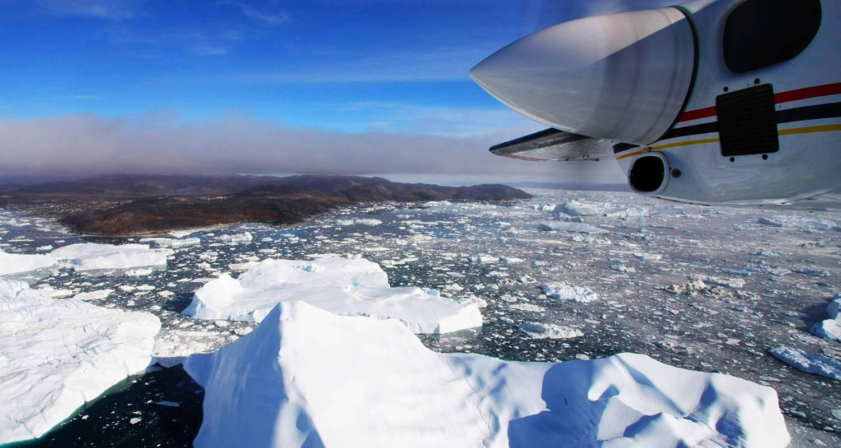

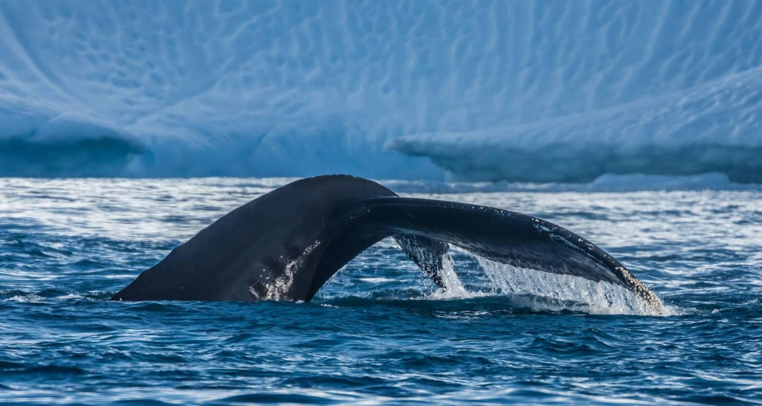

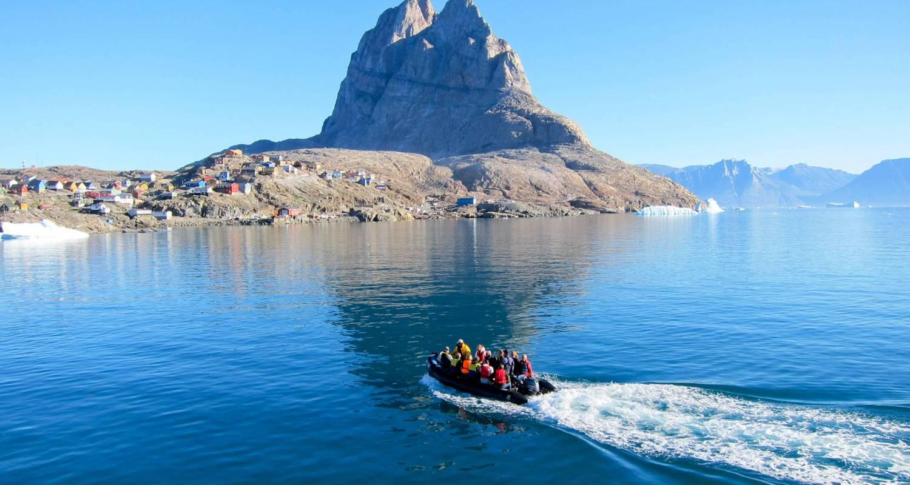

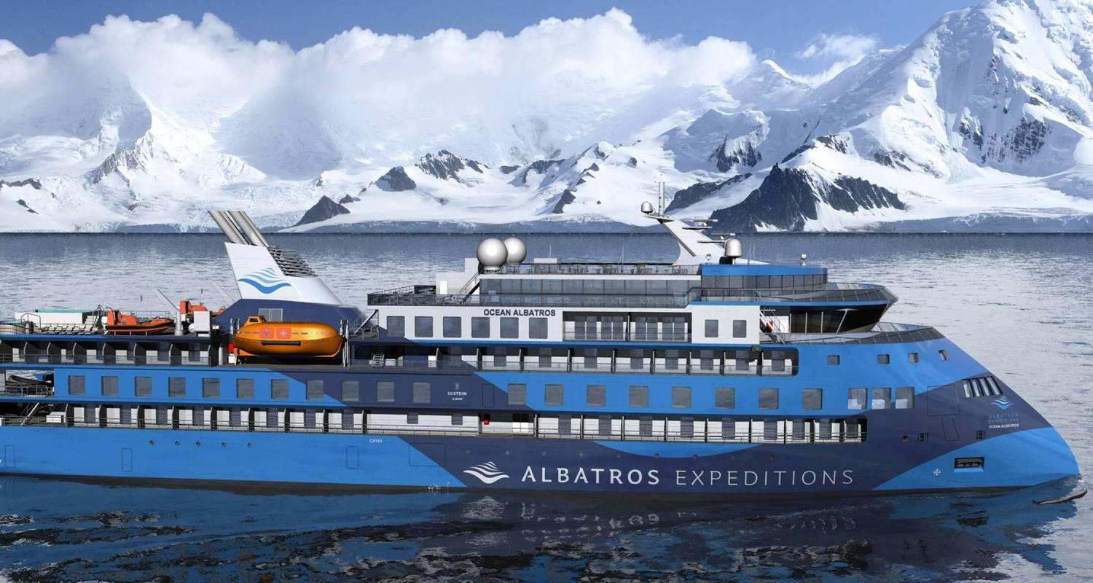

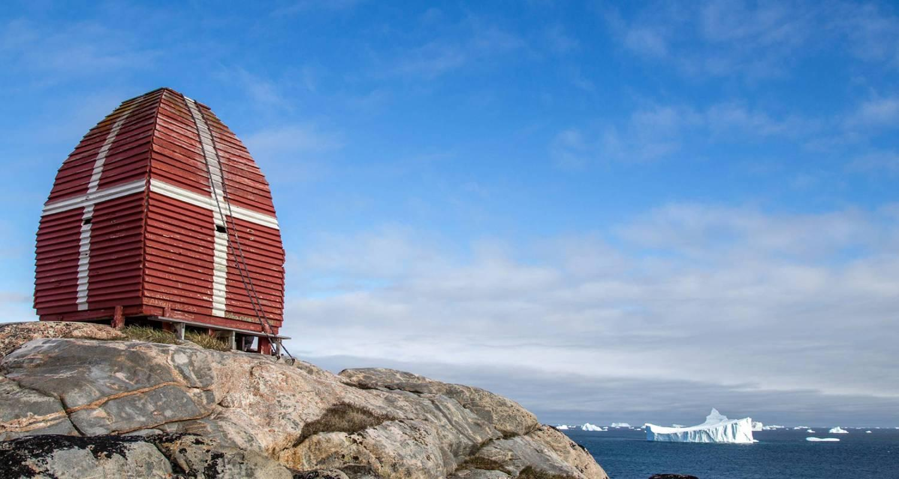

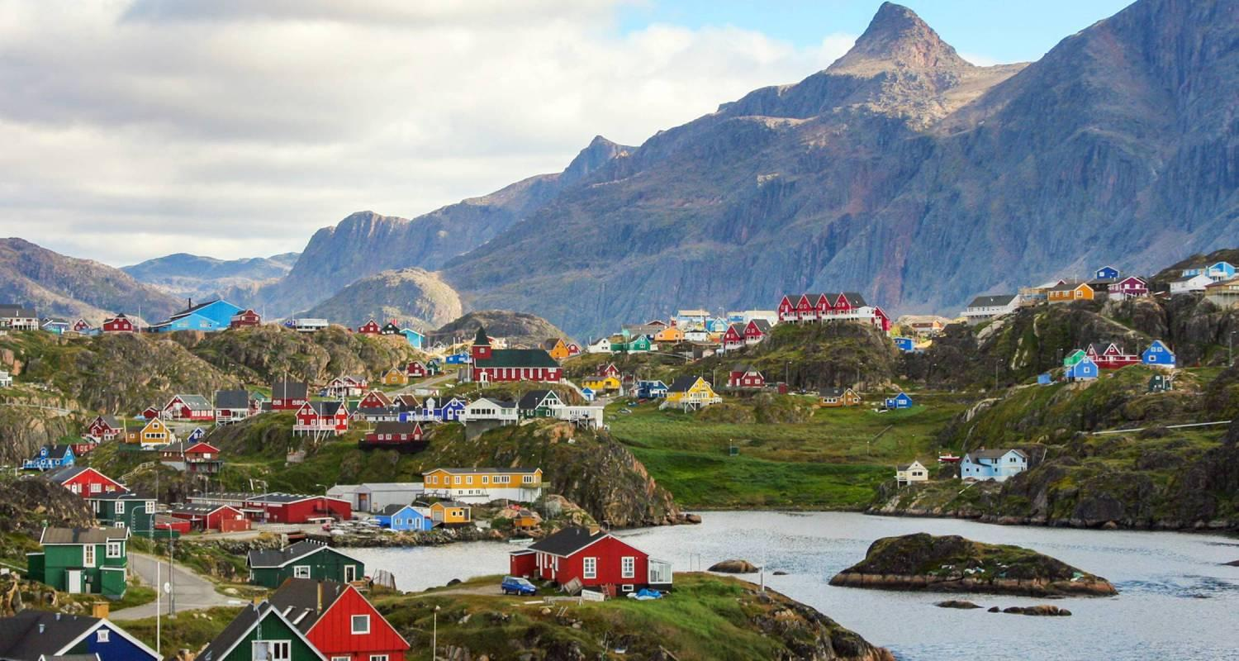

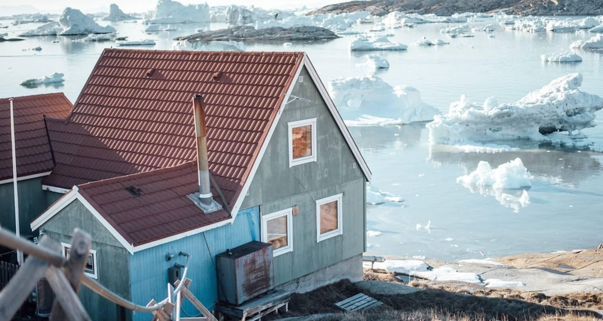

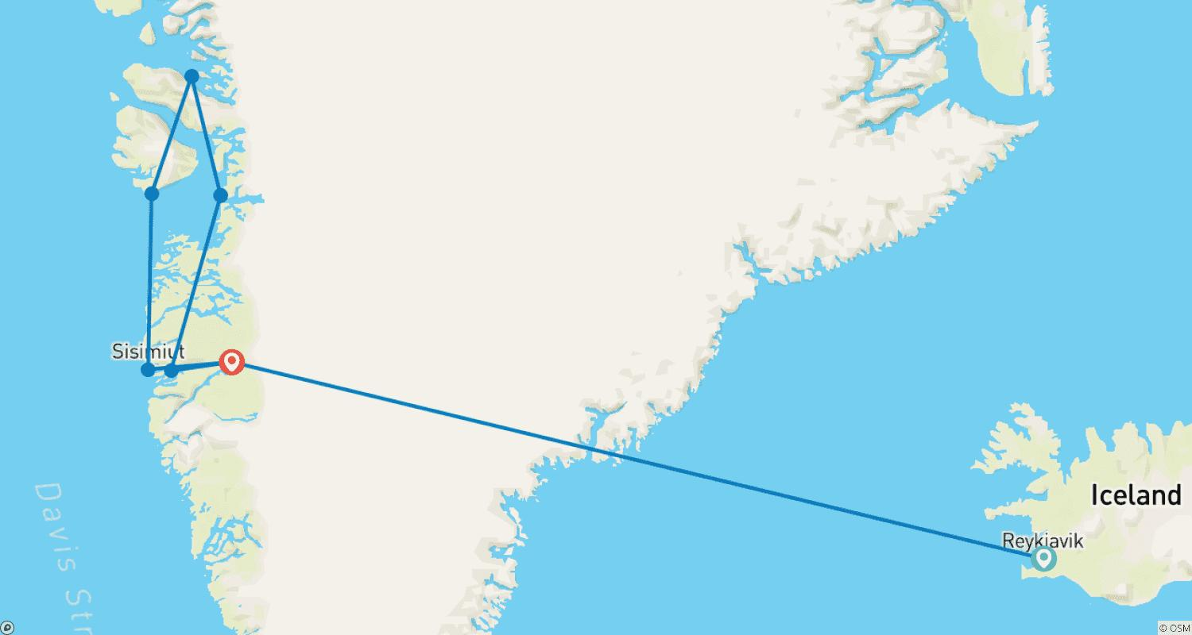

Tour ID: 230804  
Tour Name: Iceland Discovery

Tour destinations: ['Reykjavik', 'Blue Lagoon', 'Skogafoss', 'Eyjafjallajokull', 'Reynisfjara', 'Vik', 'Solheimajokull', 'Thingvellir National Park', 'Geysir', 'Gullfoss']

Tour destinations images:

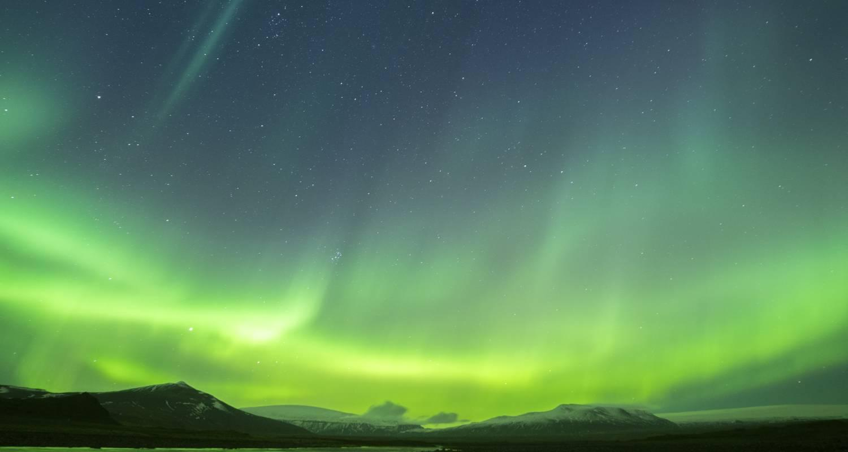

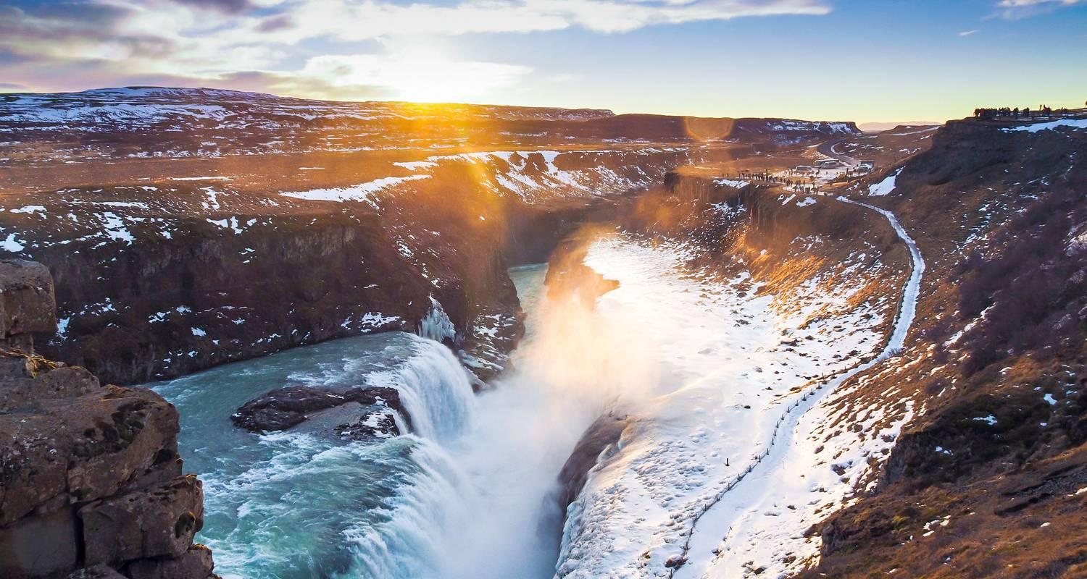

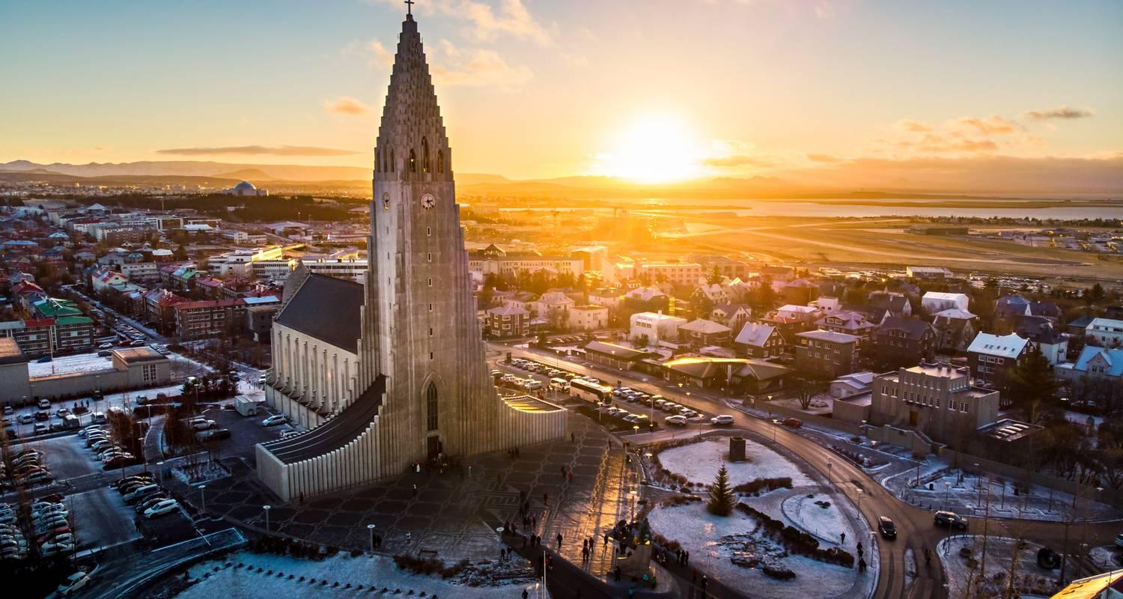

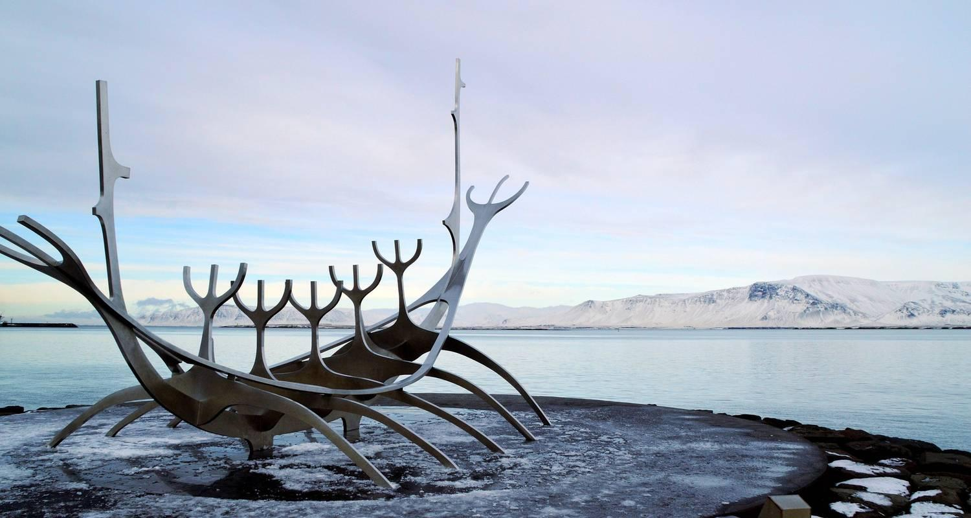

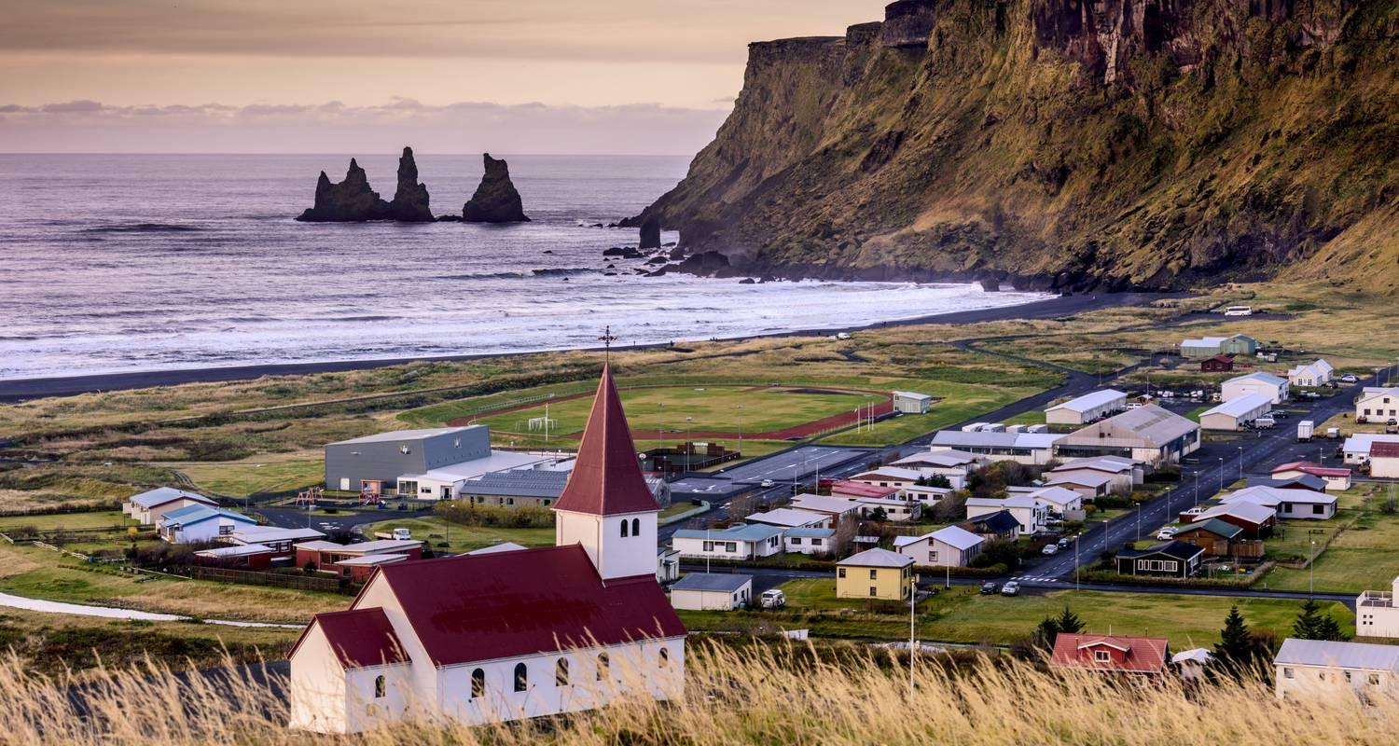

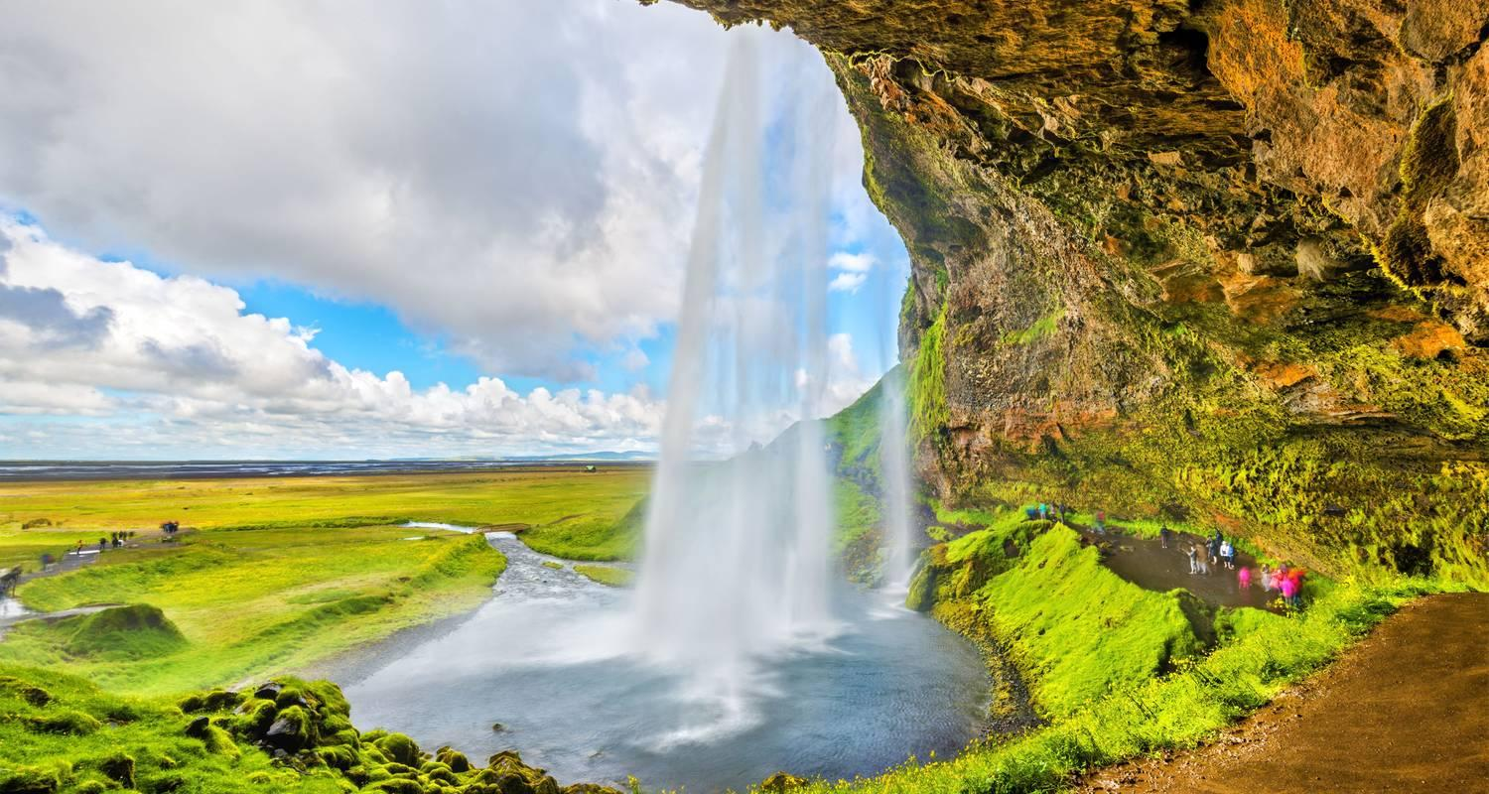

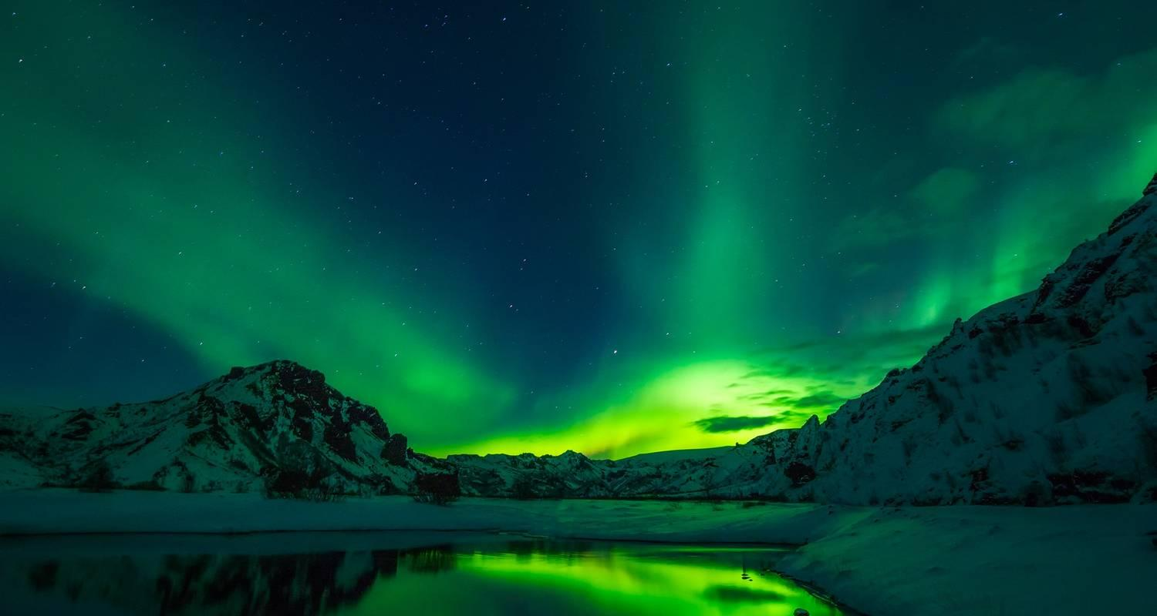

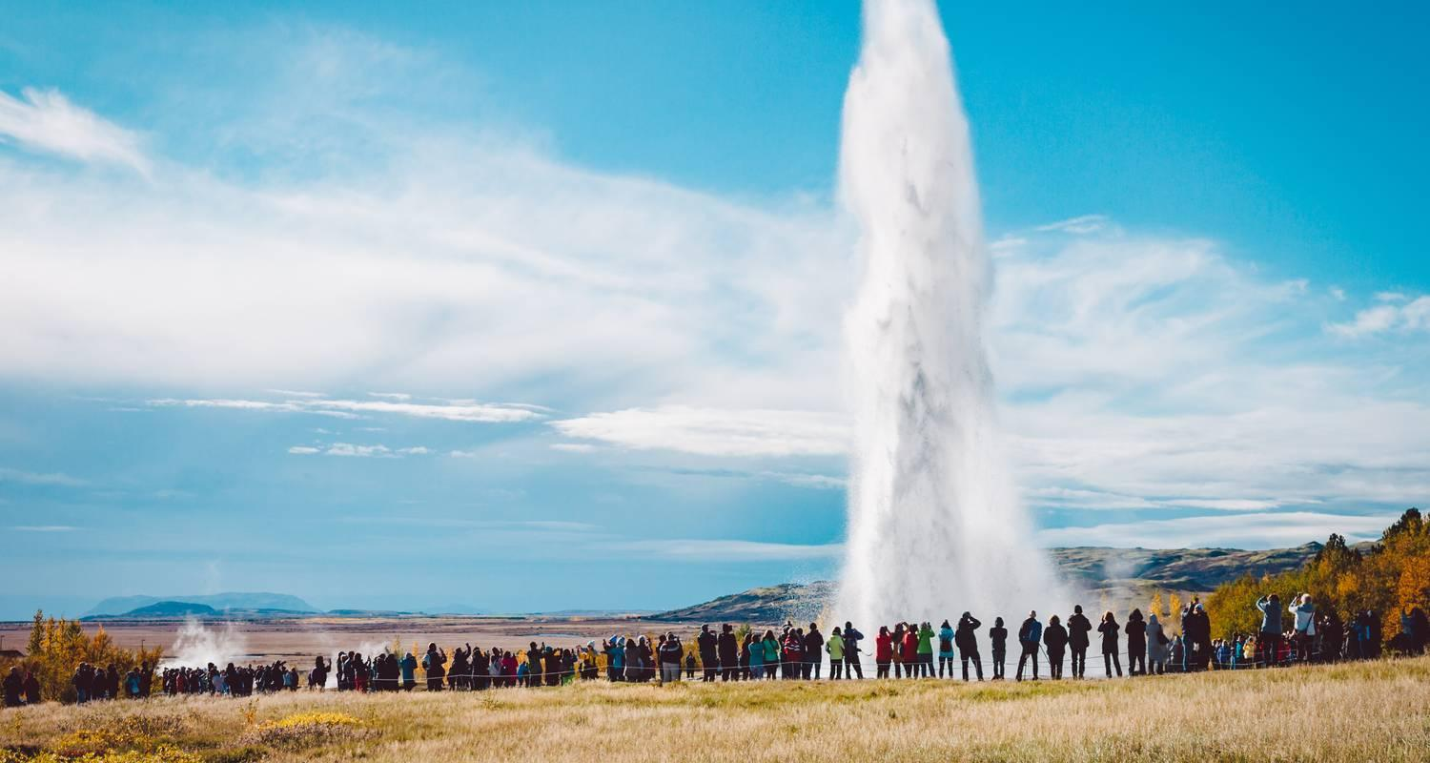

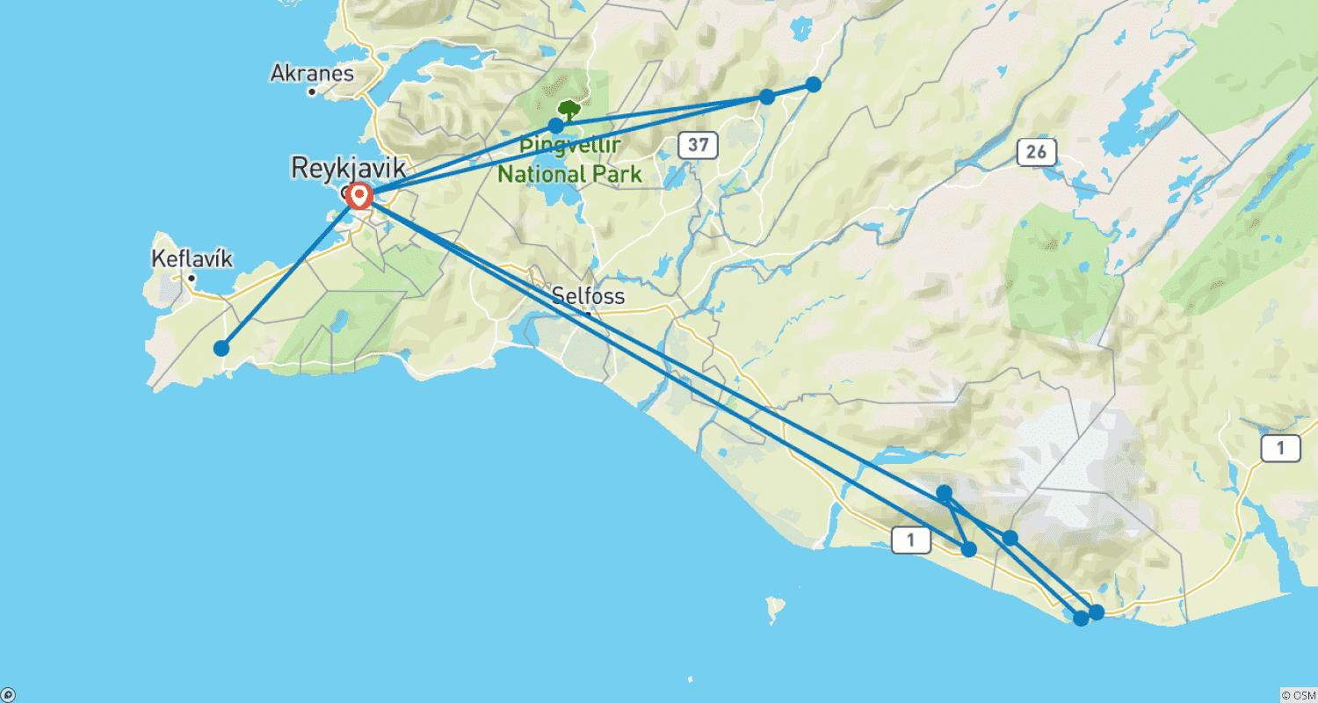

Tour ID: 231207  
Tour Name: Beyond the Arctic Circle: Svalbard, Greenland & Iceland

Tour destinations: ['Tromso', 'Svalbard', 'Spitsbergen', 'Longyearbyen', 'Isafjordur', 'Reykjavik']

Tour destinations images:

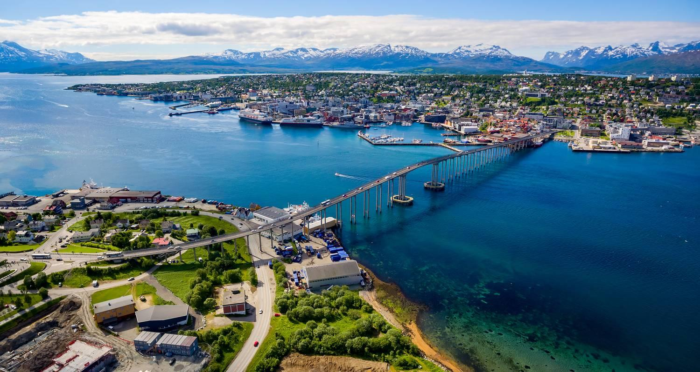

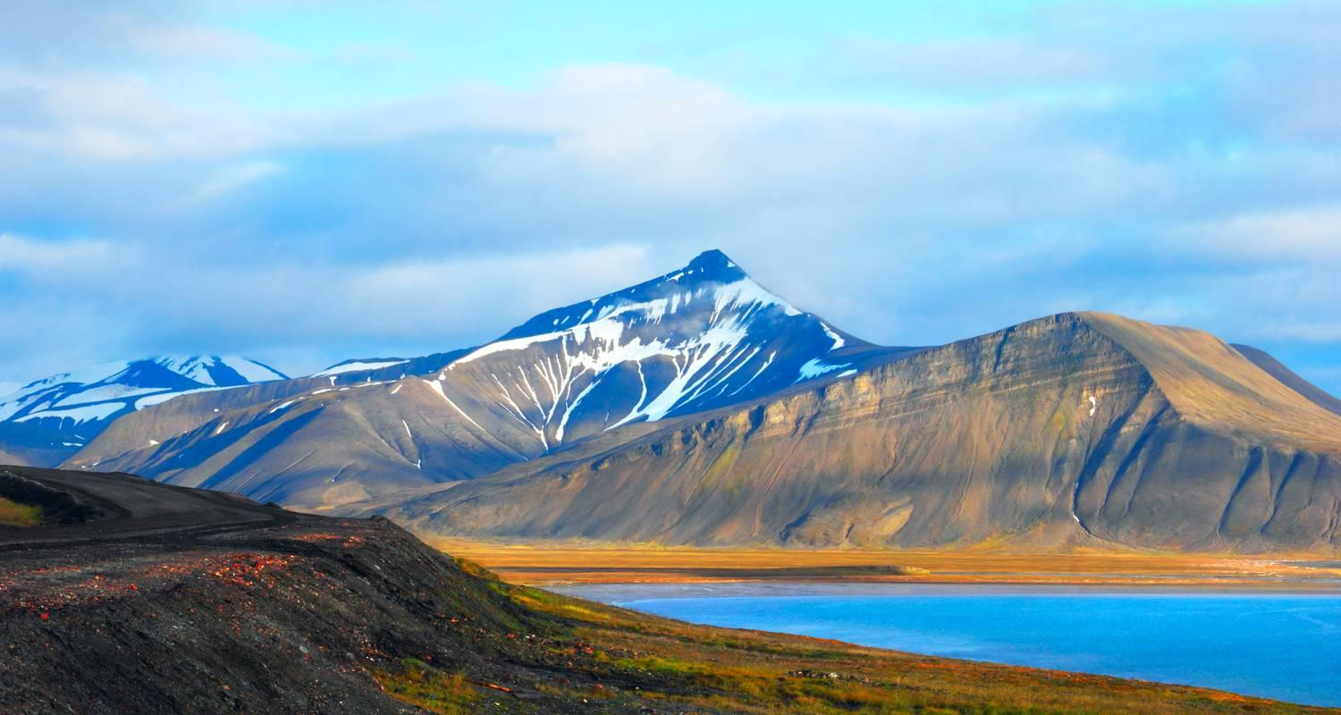



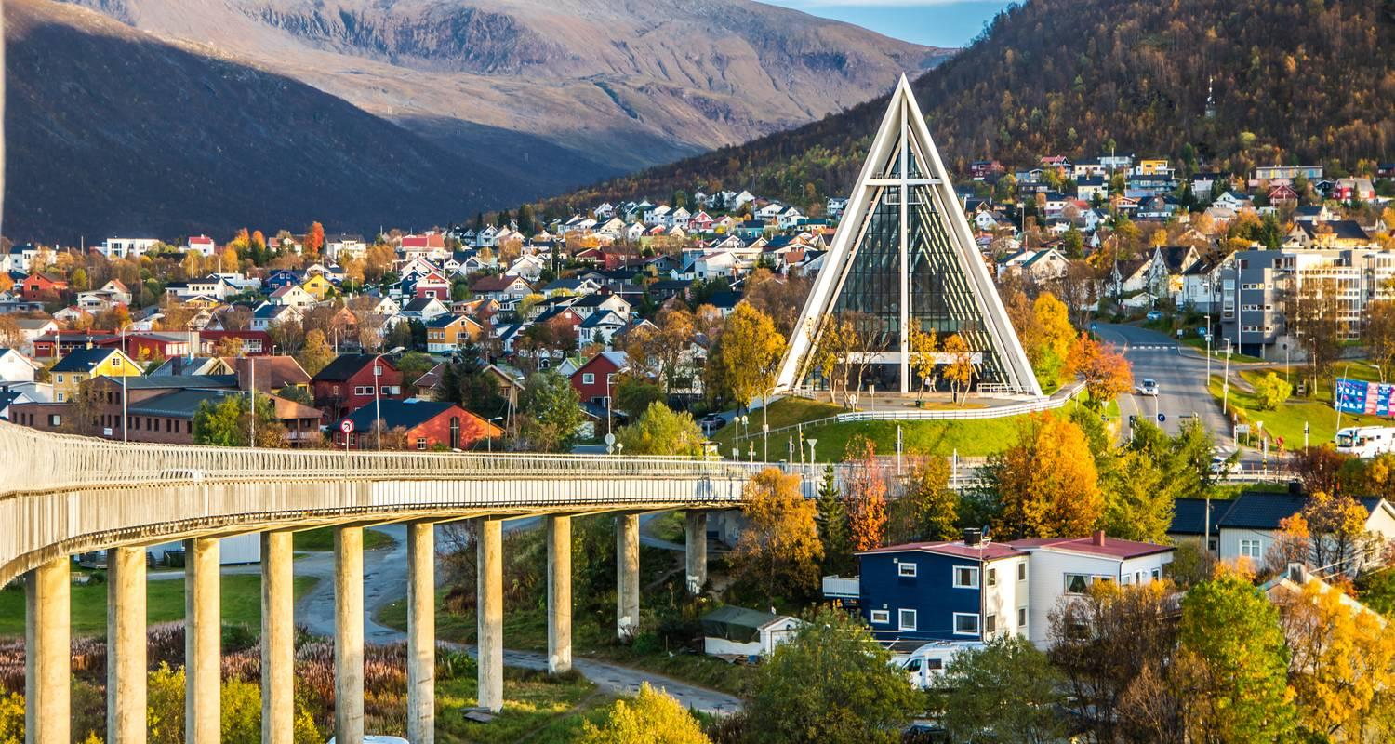

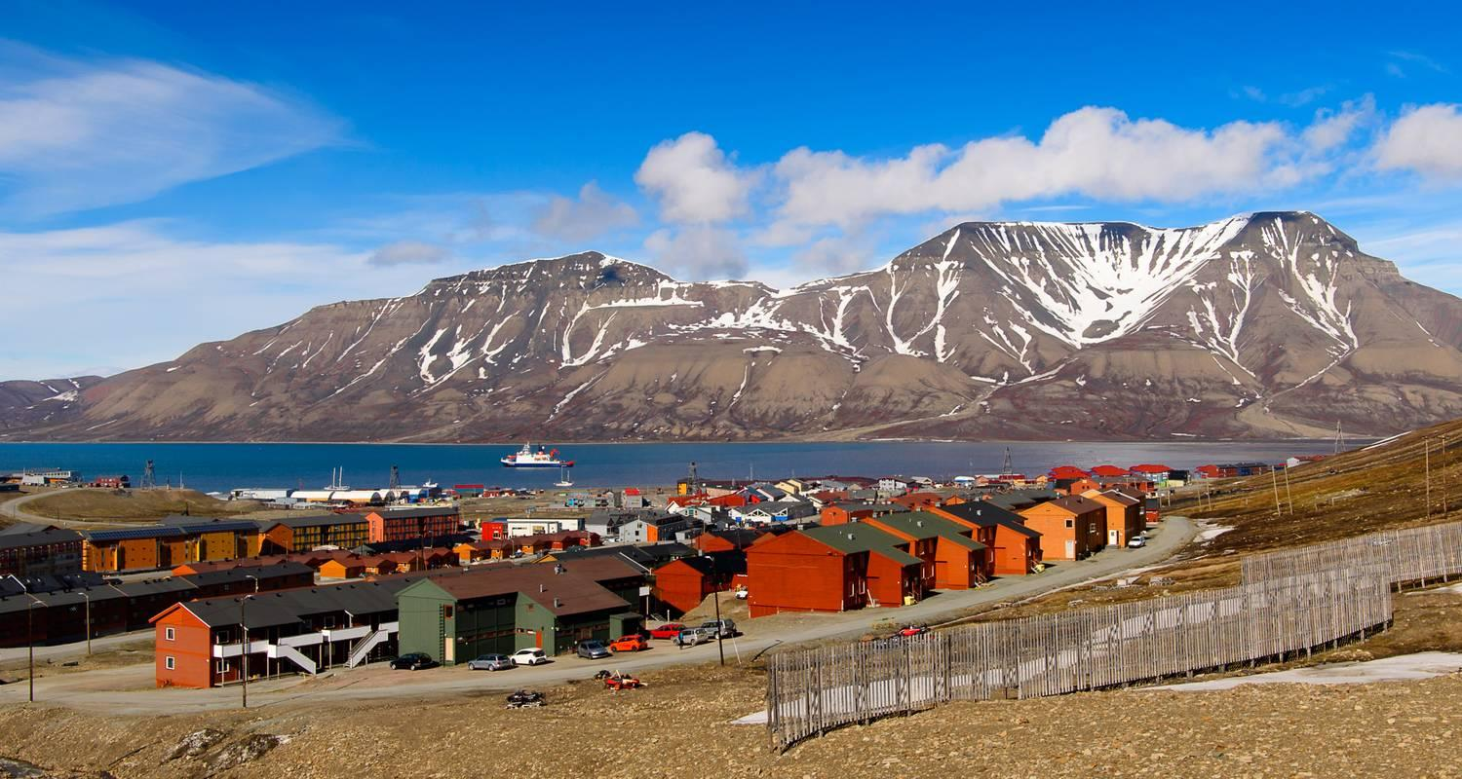

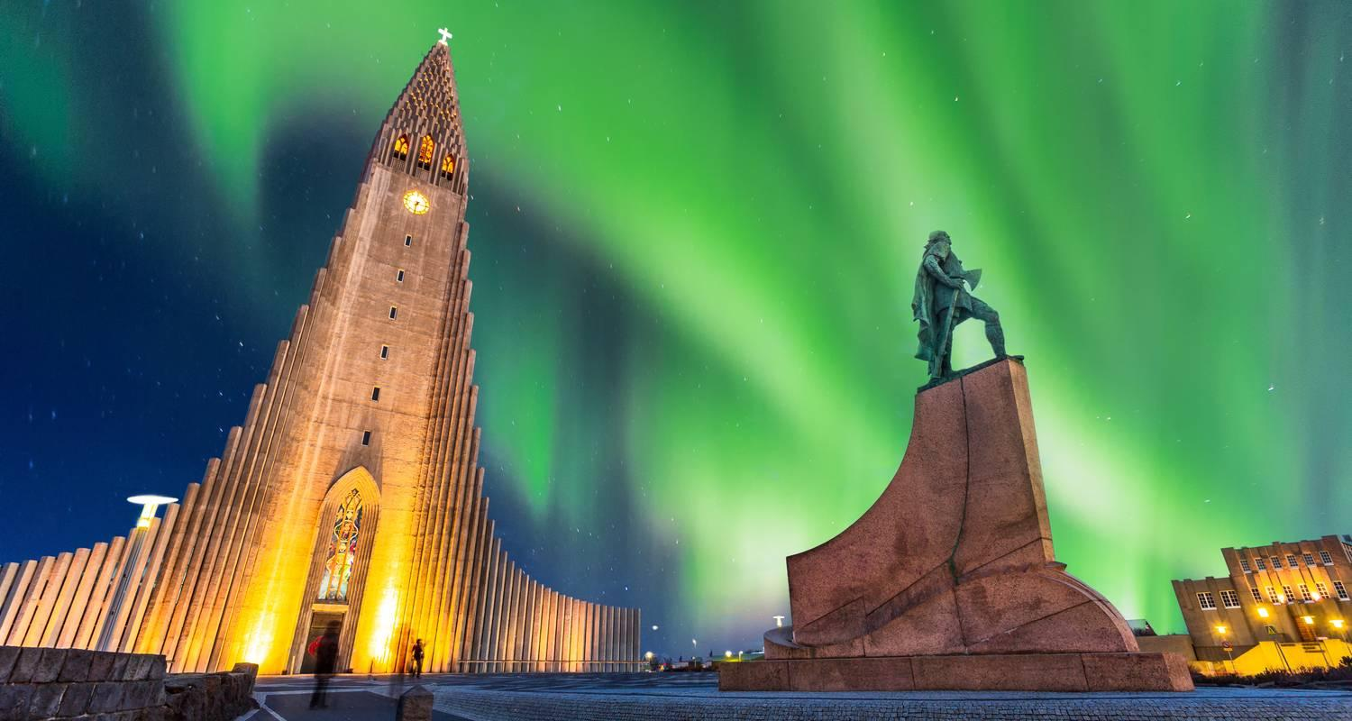

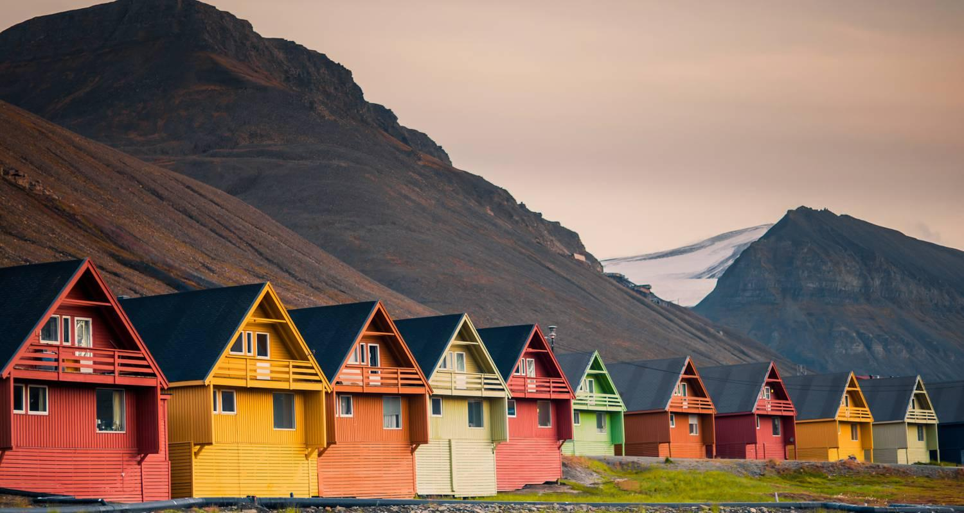

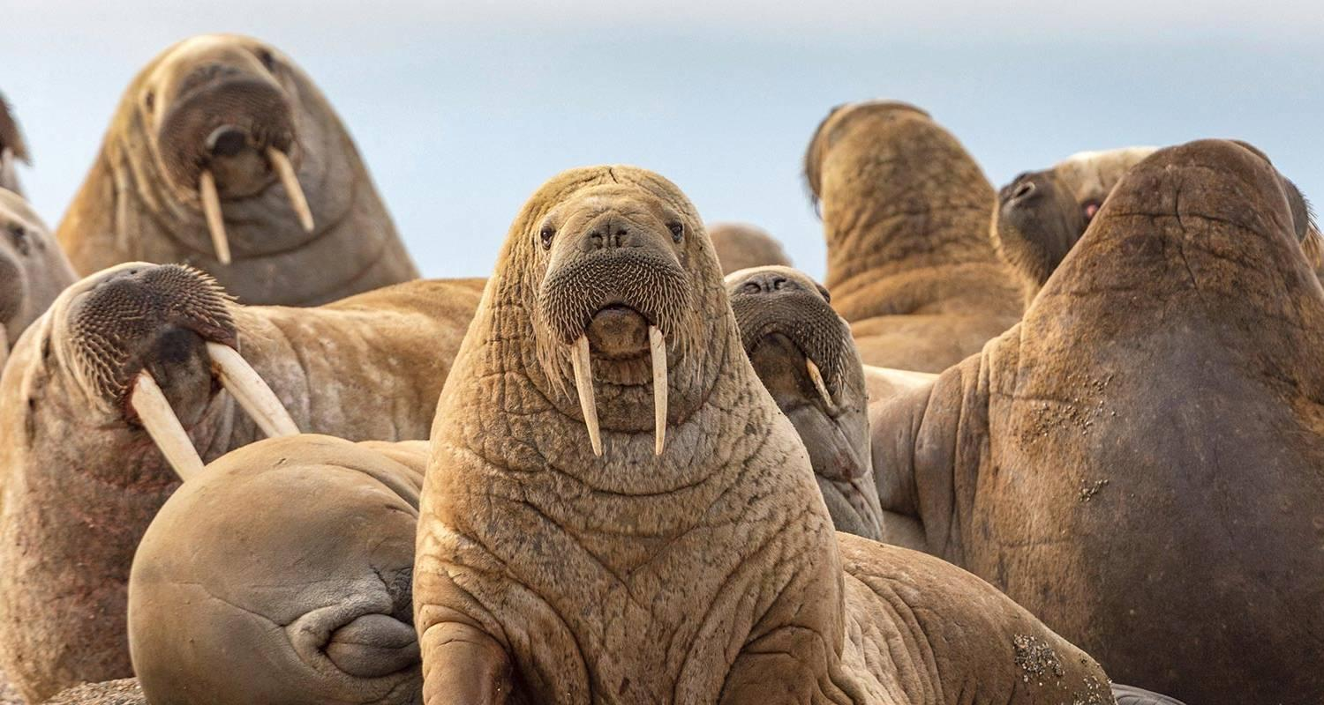

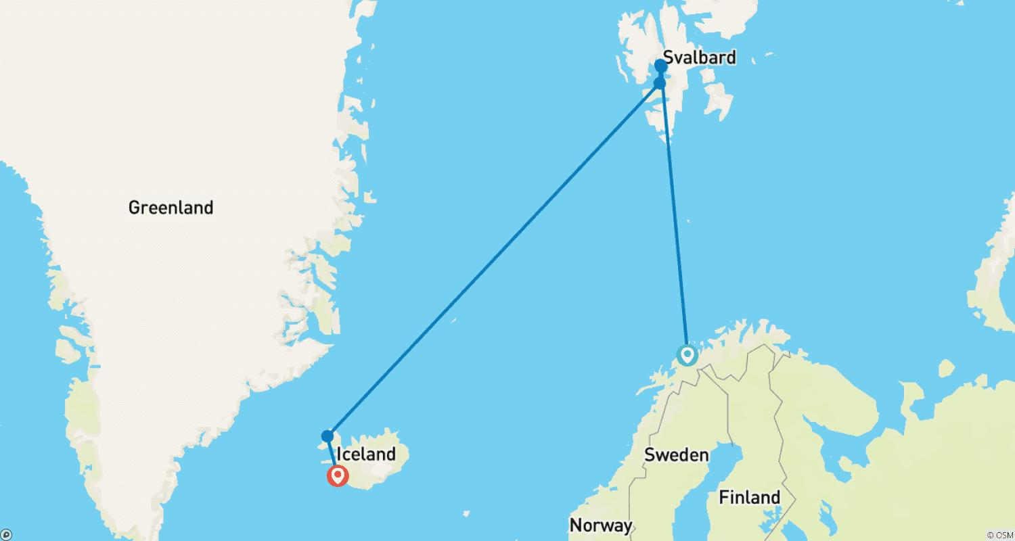

Tour ID: 231215  
Tour Name: Ultimate Greenland & High Canadian Arctic

Tour destinations: ['Reykjavik', 'Skjoldungen', 'Prins Christianssund', 'Narsaq', 'Nuuk', 'Evighedsfjorden', 'Ilulissat', 'Upernavik', 'Disko Bay', 'Sisimiut', 'Kangerlussuaq', 'Melville Island', 'Qaanaaq', 'Pond Inlet', 'Copenhagen']

Tour destinations images:





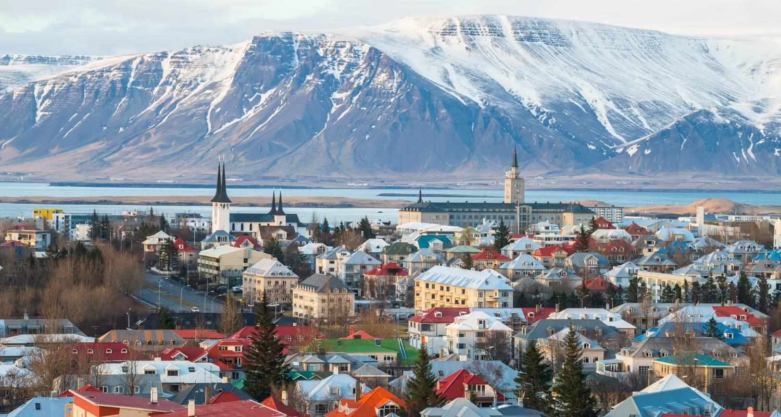

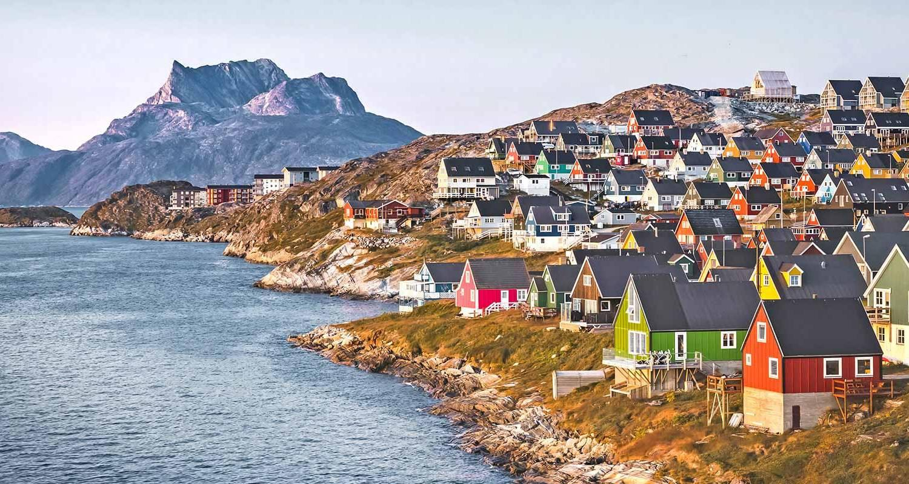

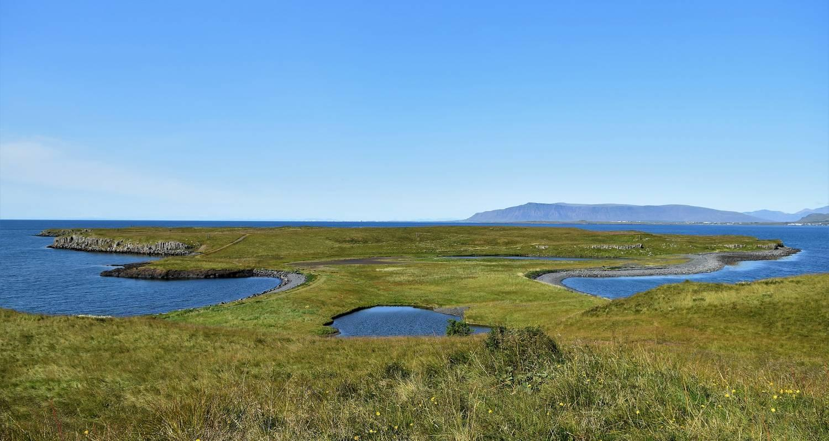

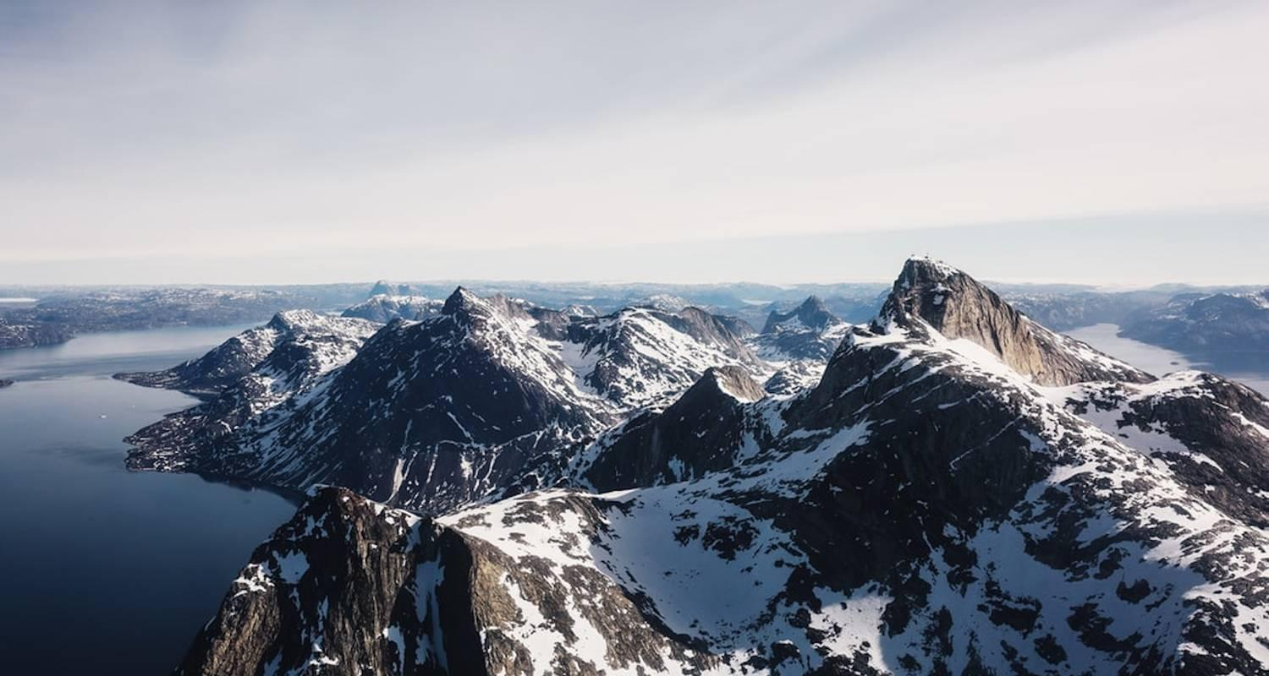

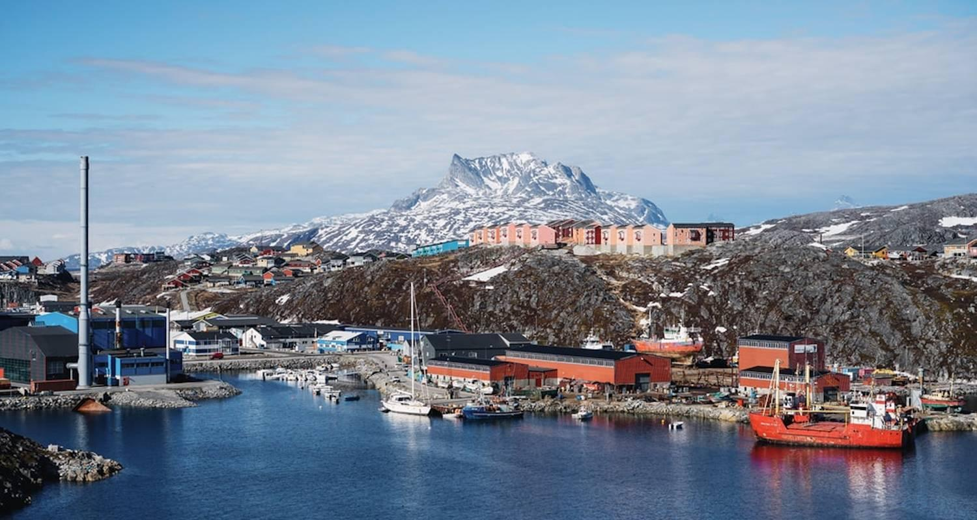

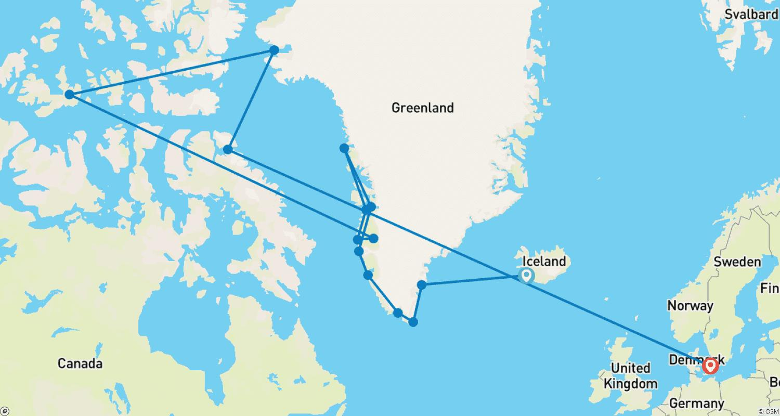

Tour ID: 231427  
Tour Name: 6 day Guided tour | Hidden Powers & Northern Lights Hunt

Tour destinations: ['Reykjavik', 'Thingvellir National Park', 'Geysir', 'Gullfoss', 'Seljaland', 'Eyjafjallajokull', 'Skogafoss', 'Reynisfjara', 'Kirkjubaejarklaustur', 'Skaftafell', 'Jokulsarlon', 'Vik', 'Hveragerdi', 'Blue Lagoon']

Tour destinations images:

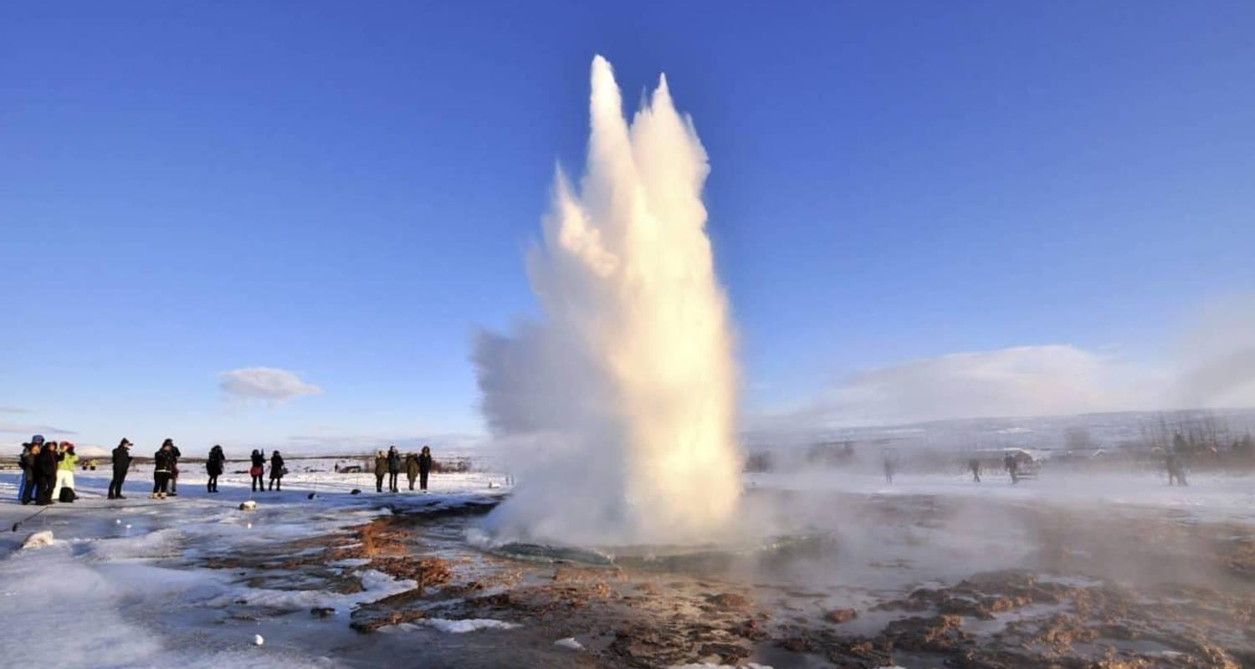

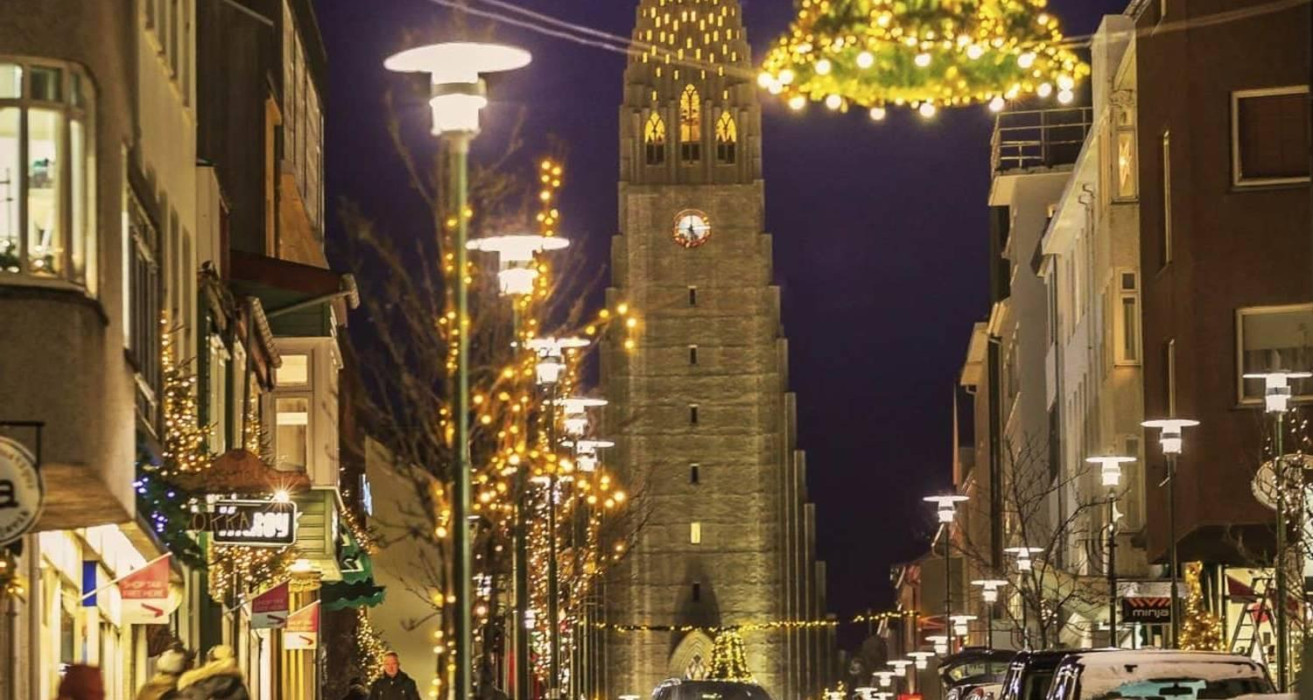

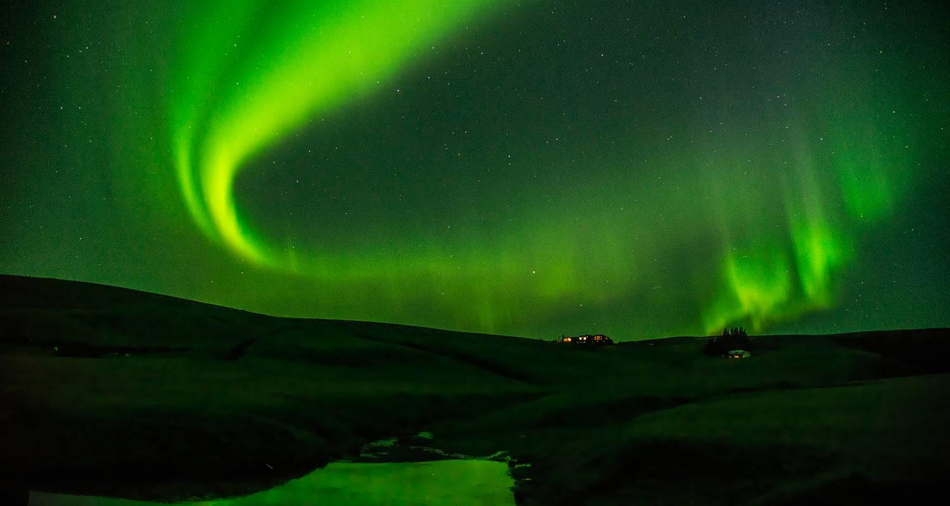

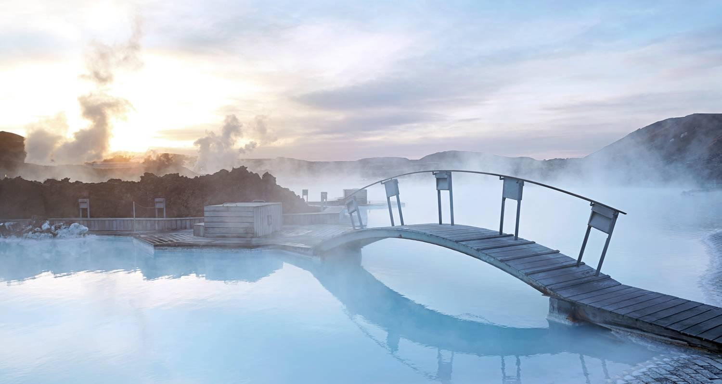

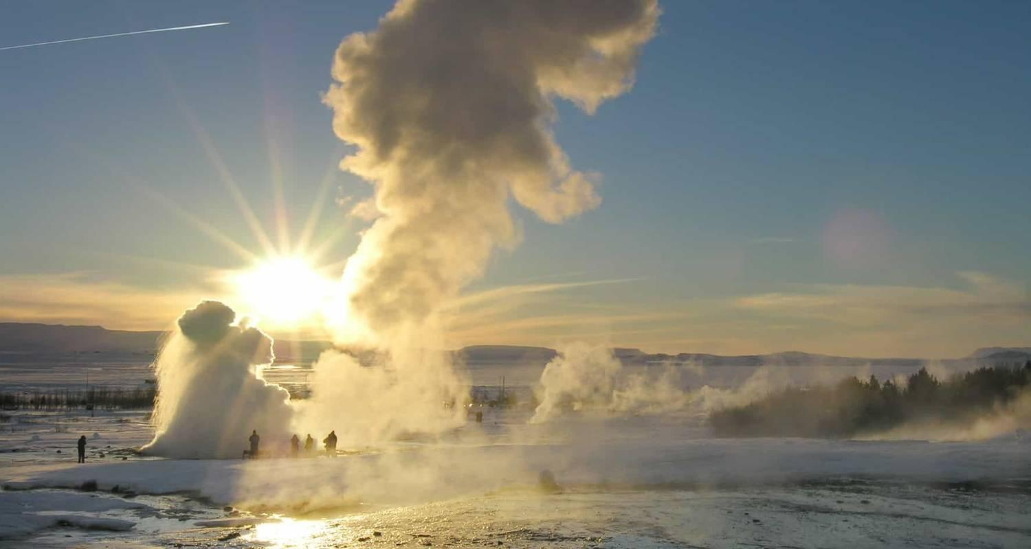

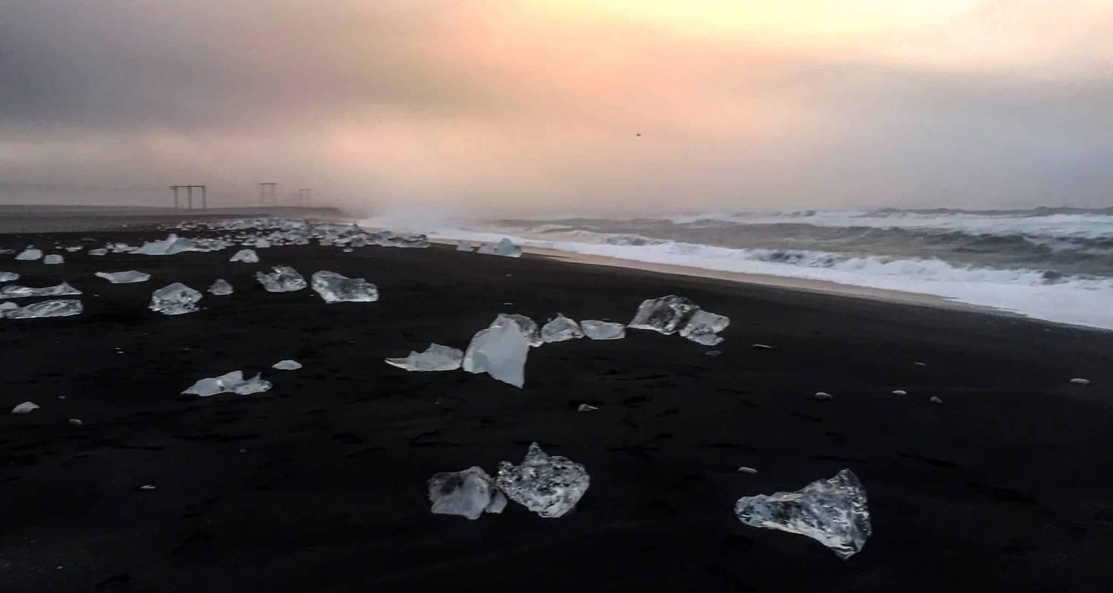

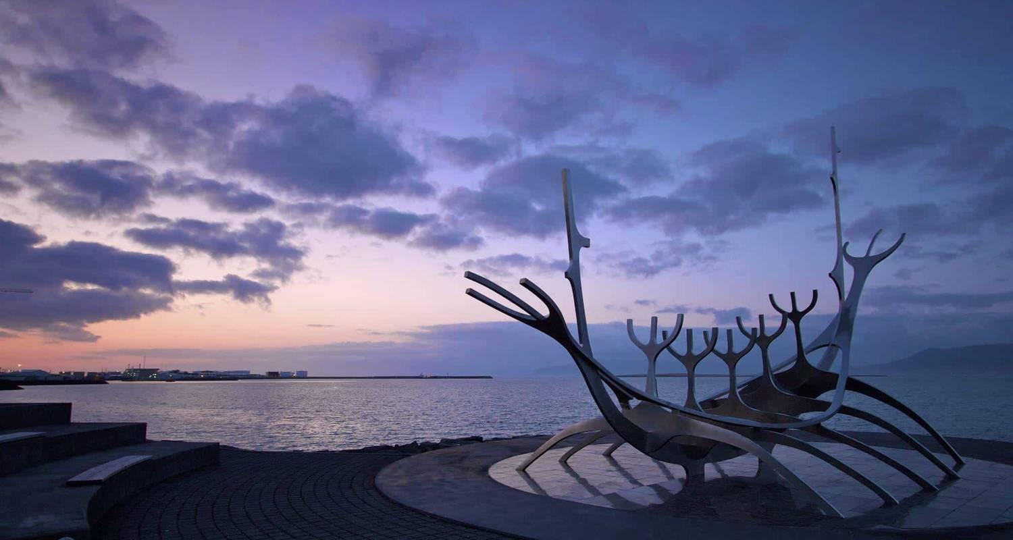

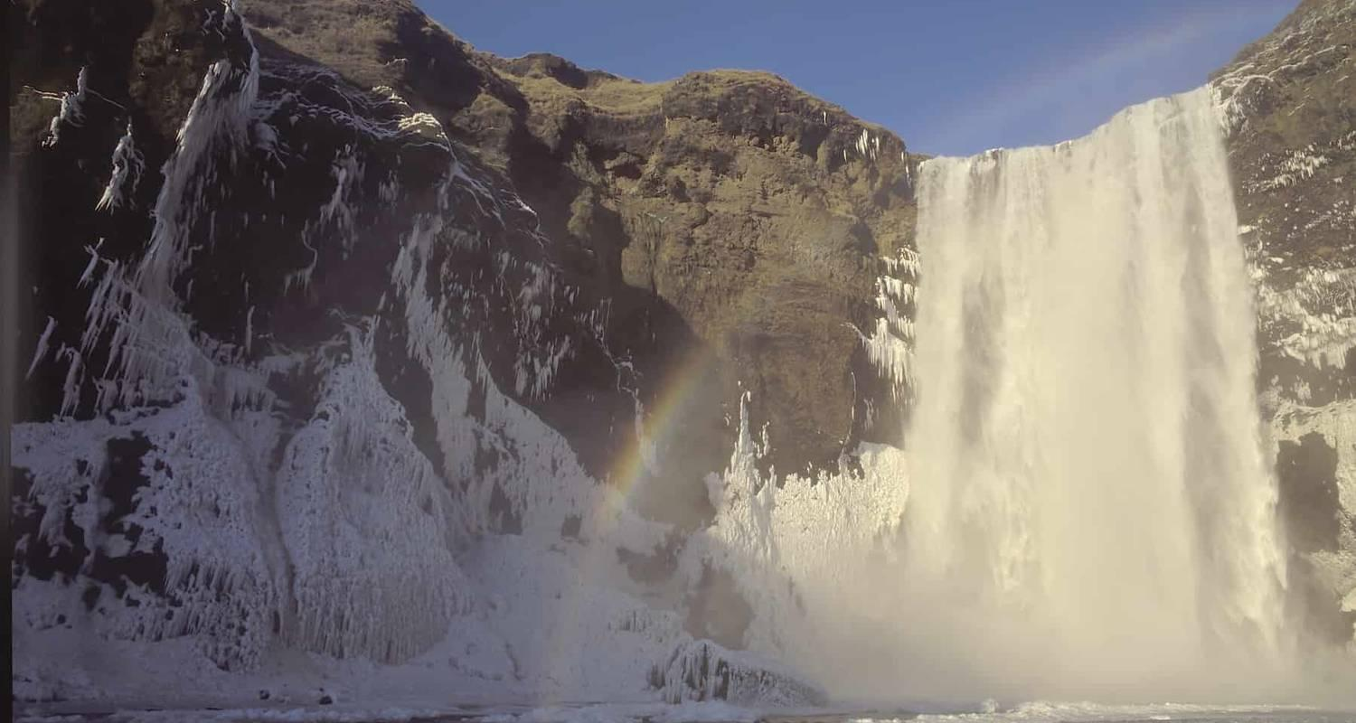

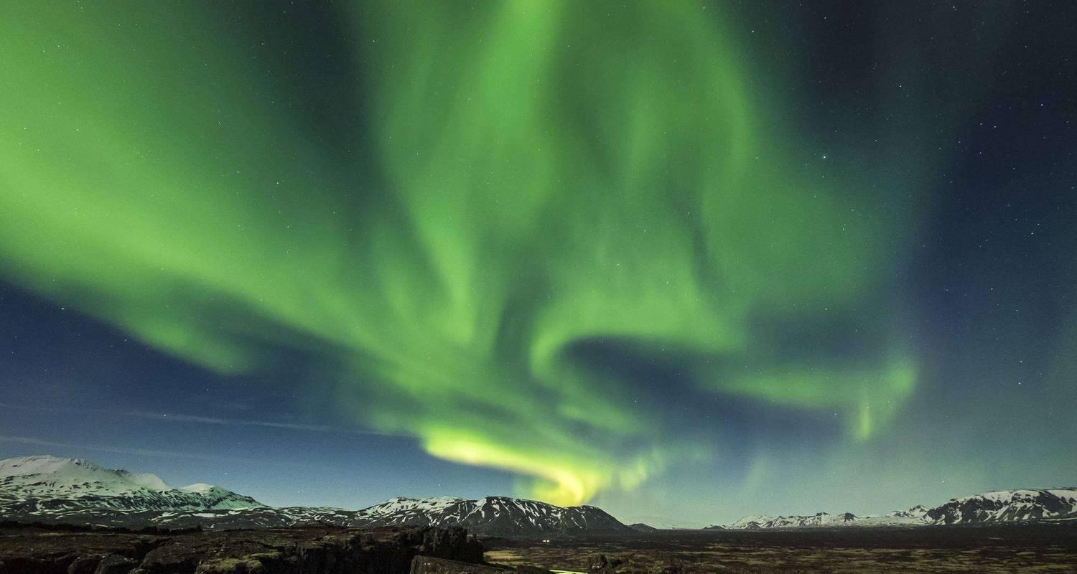

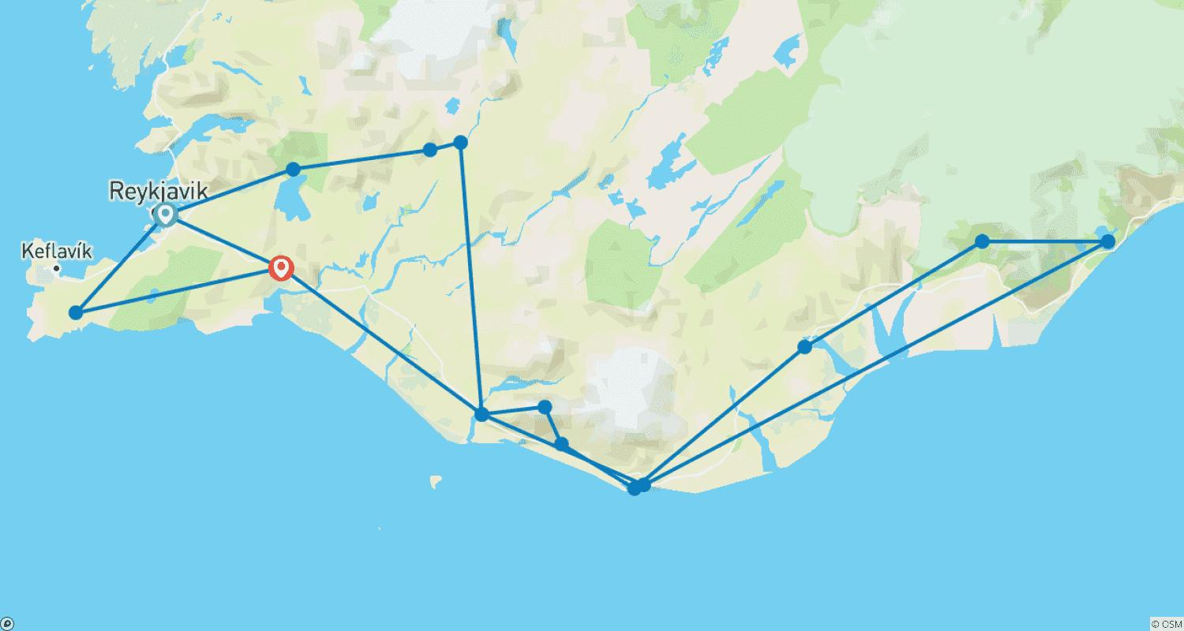

Tour ID: 234033  
Tour Name: Iceland North & South - 6 days

Tour destinations: ['Reykjavik', 'Thingvellir National Park', 'Geysir', 'Gullfoss', 'Skogafoss', 'Reynisfjara', 'Vik', 'Skaftafell', 'Hofn', 'Jokulsarlon', 'Egilsstadir', 'Djupivogur', 'Myvatn', 'Akureyri', 'Dettifoss', 'Godafoss', 'Dalvik', 'Hraunfossar', 'Reykholt']

Tour destinations images:

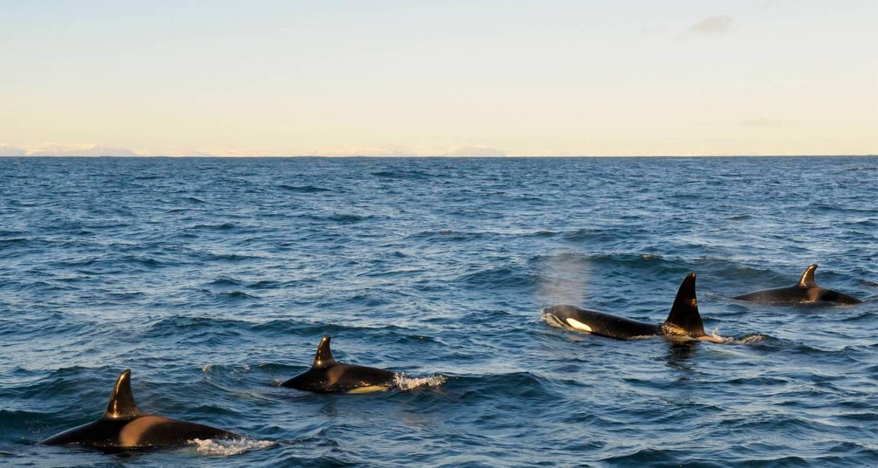

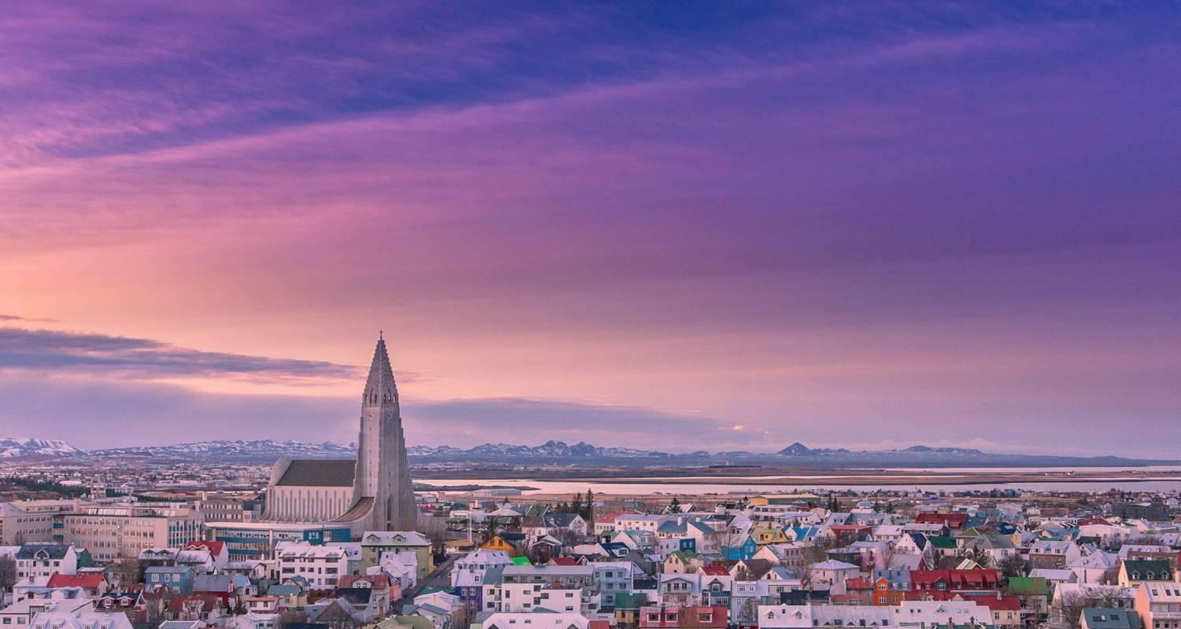

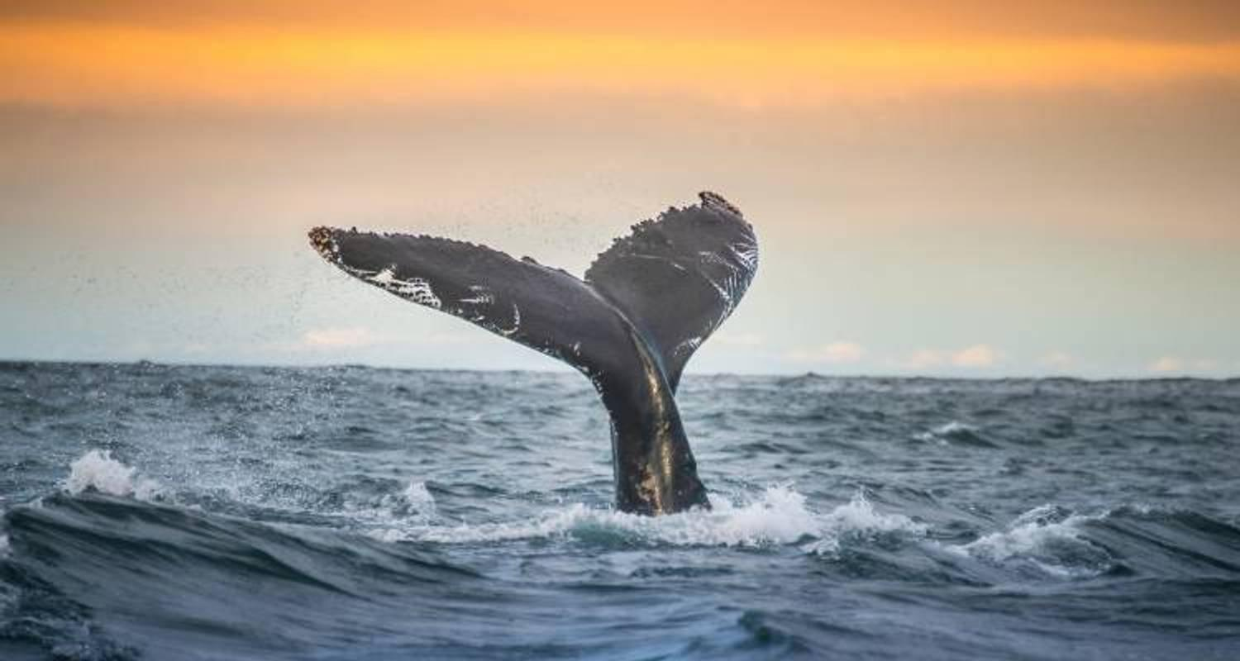

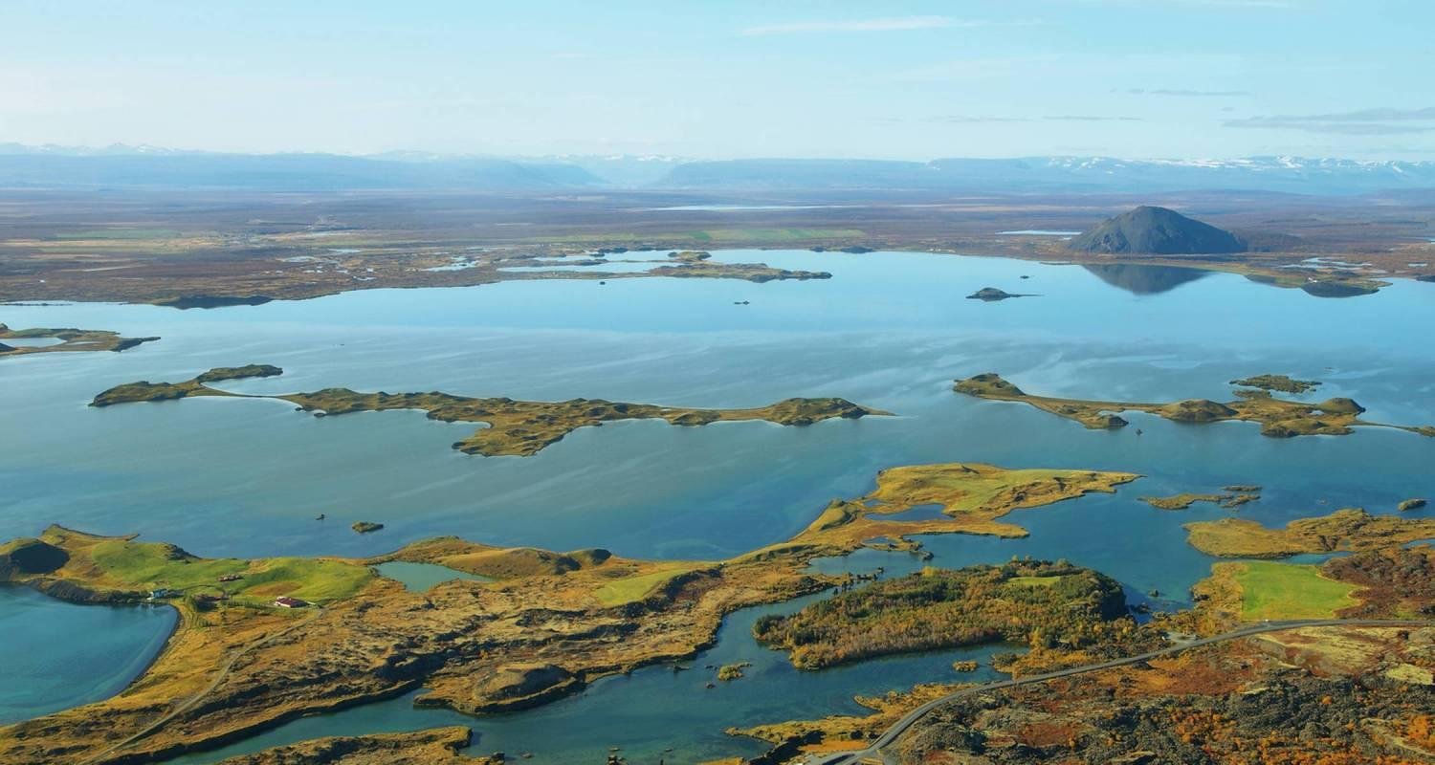

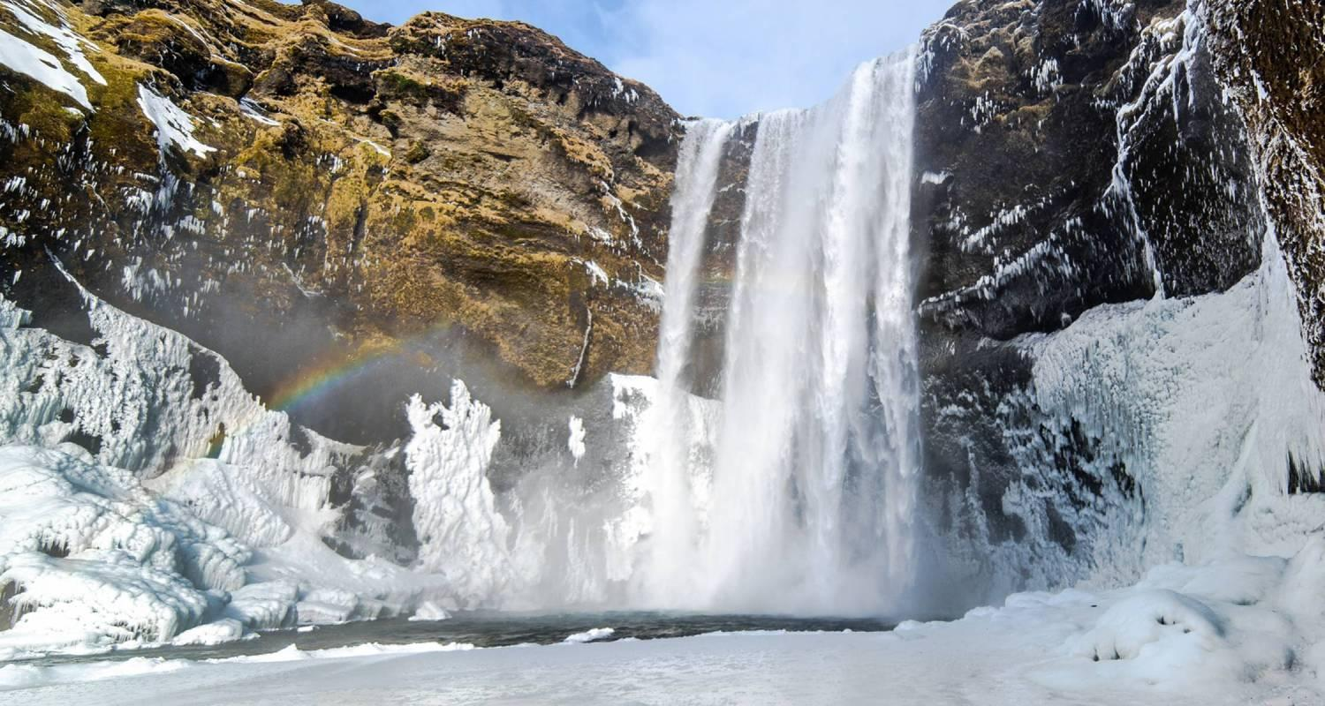

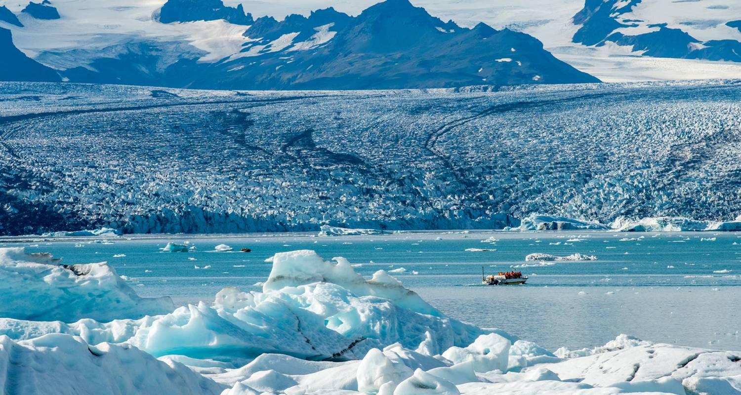

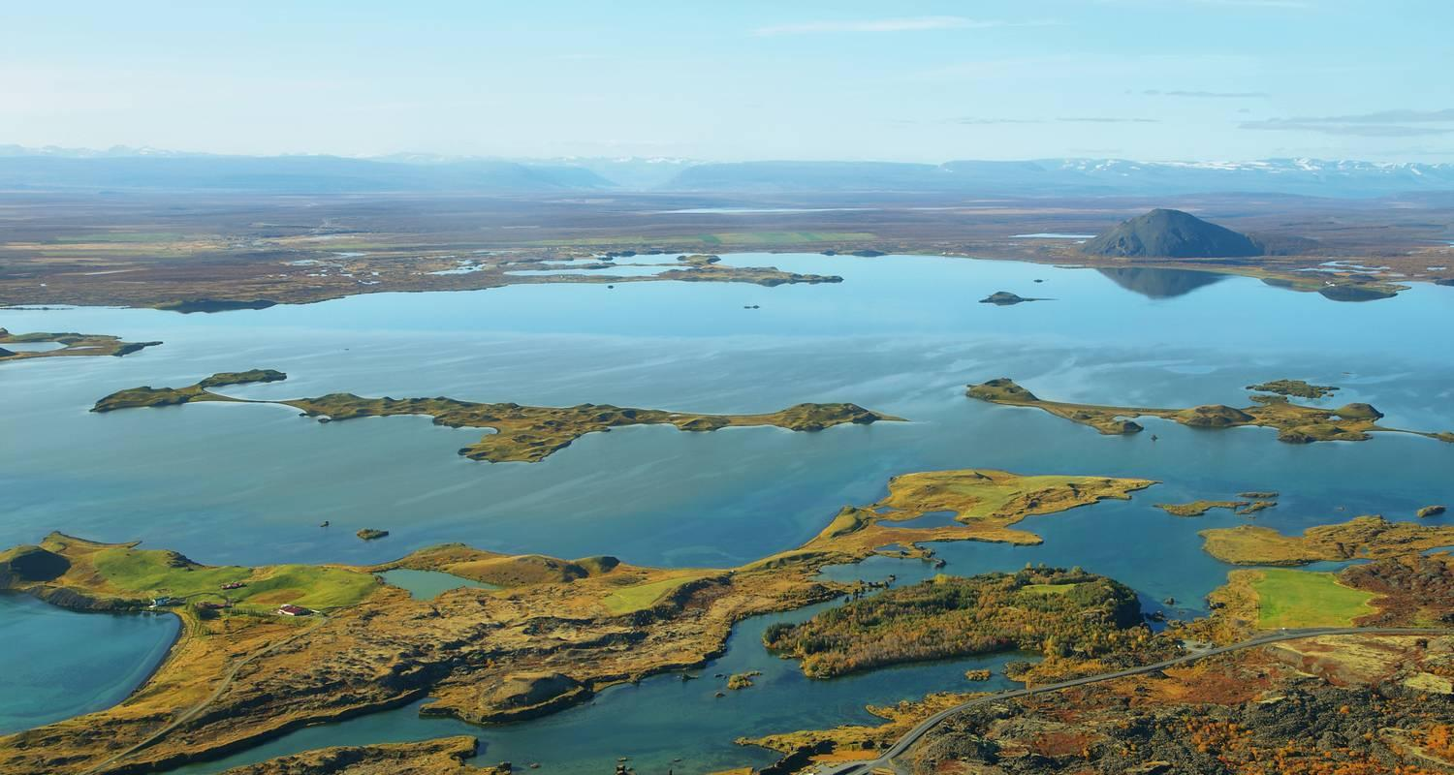

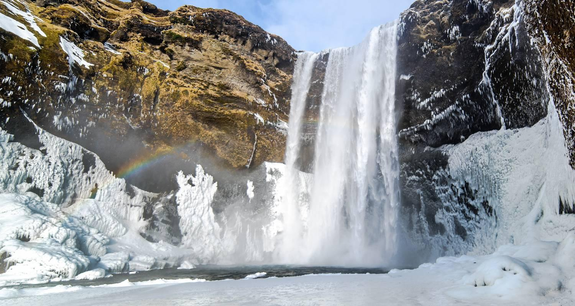

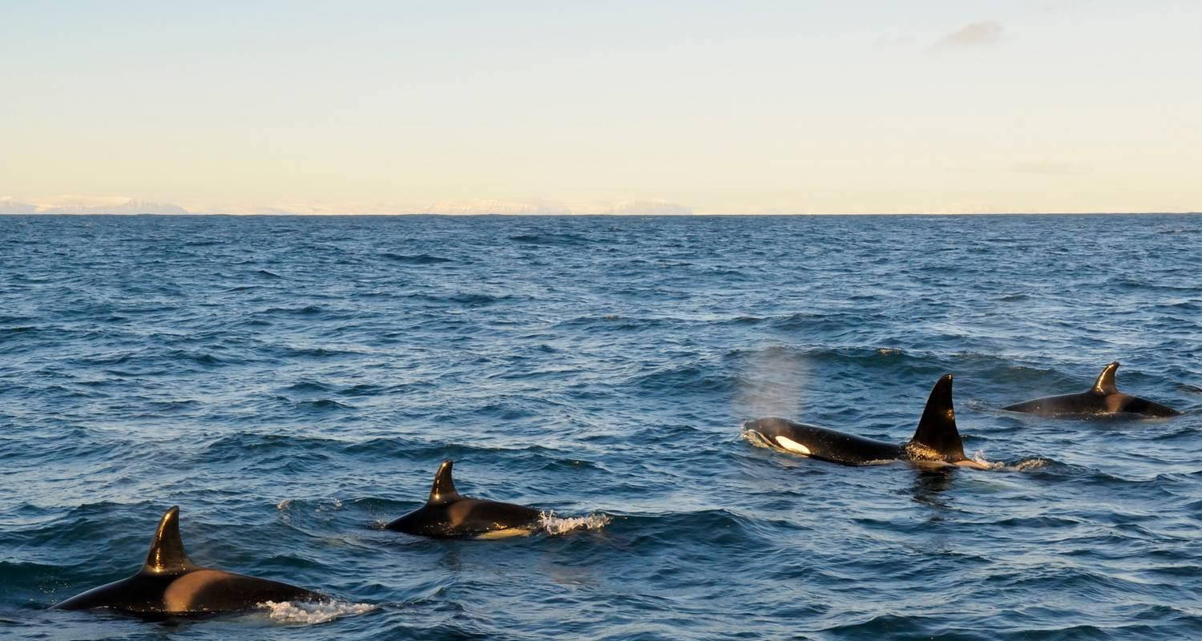

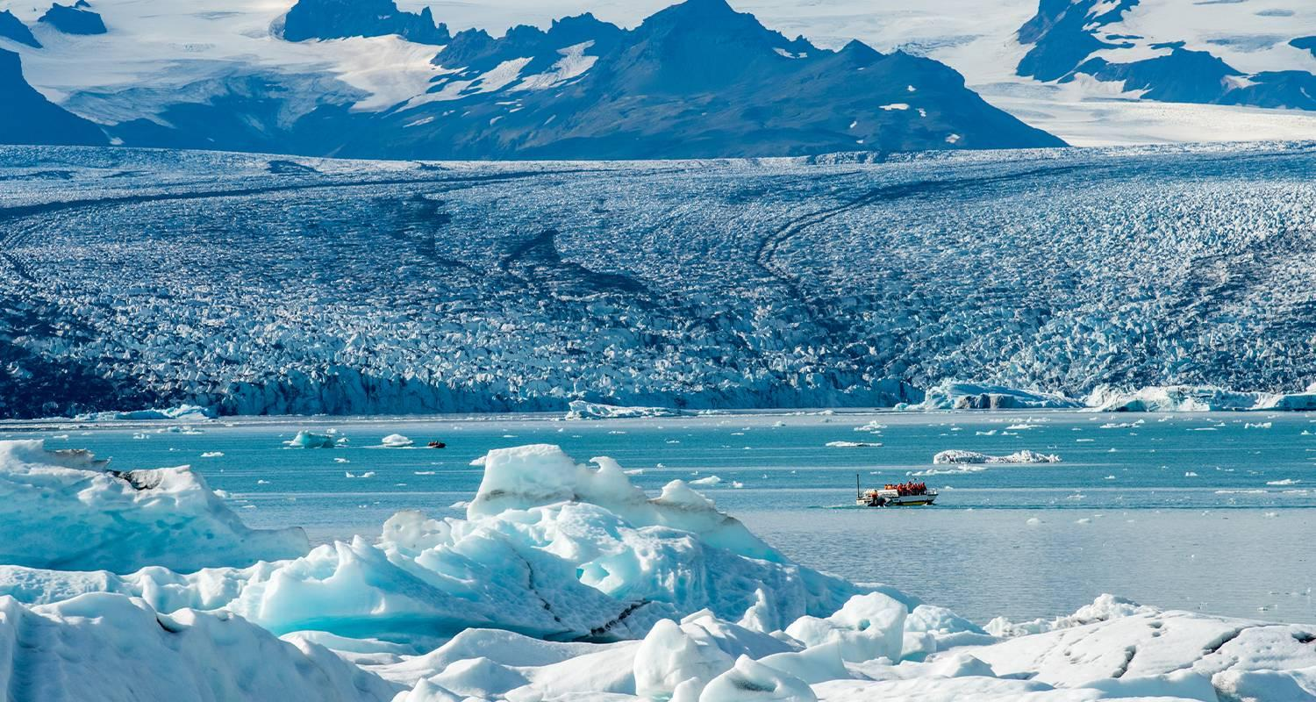

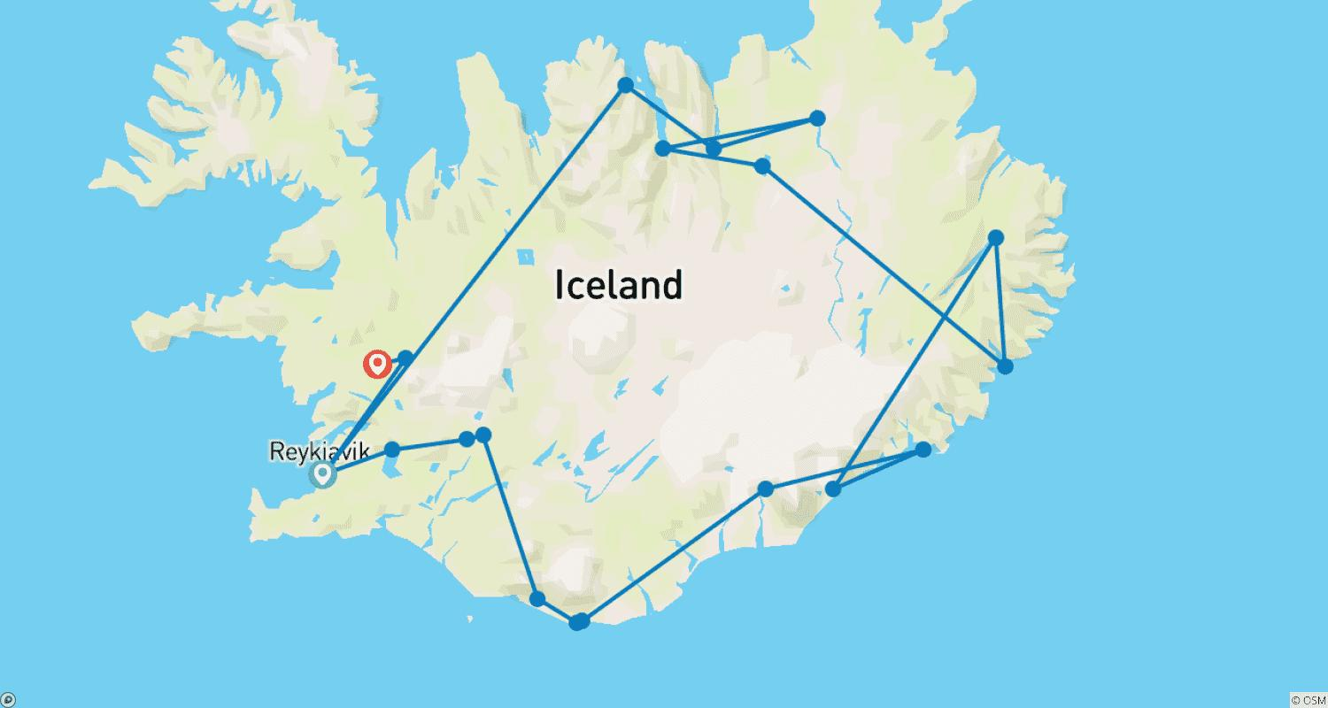

Tour ID: 234034  
Tour Name: Iceland Overnight Adventure - 2 Days

Tour destinations: ['Reykjavik', 'Hof']

Tour destinations images:





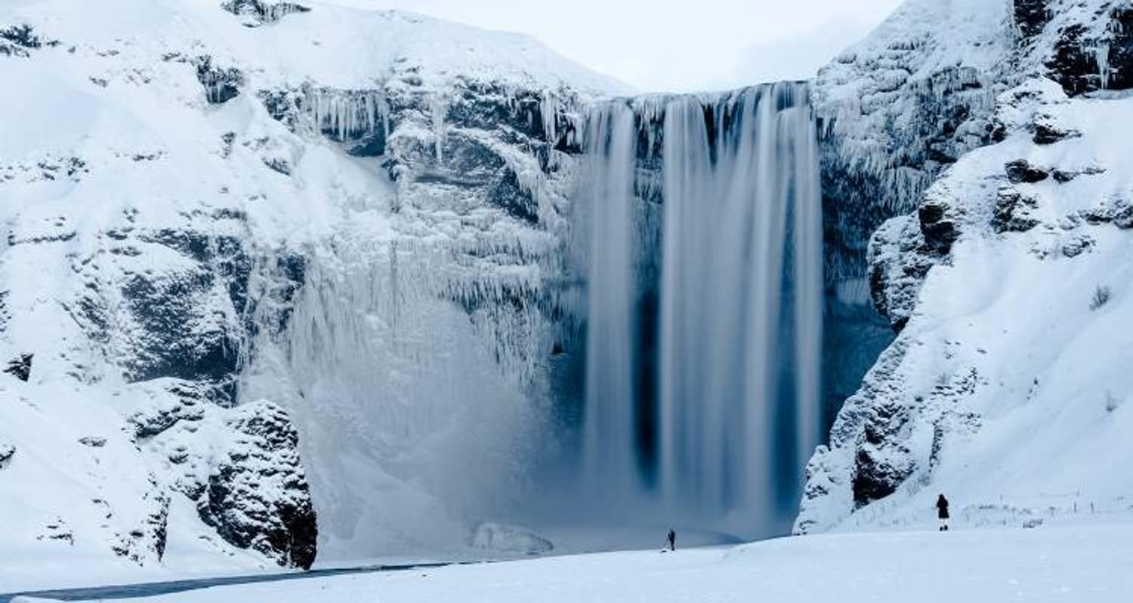

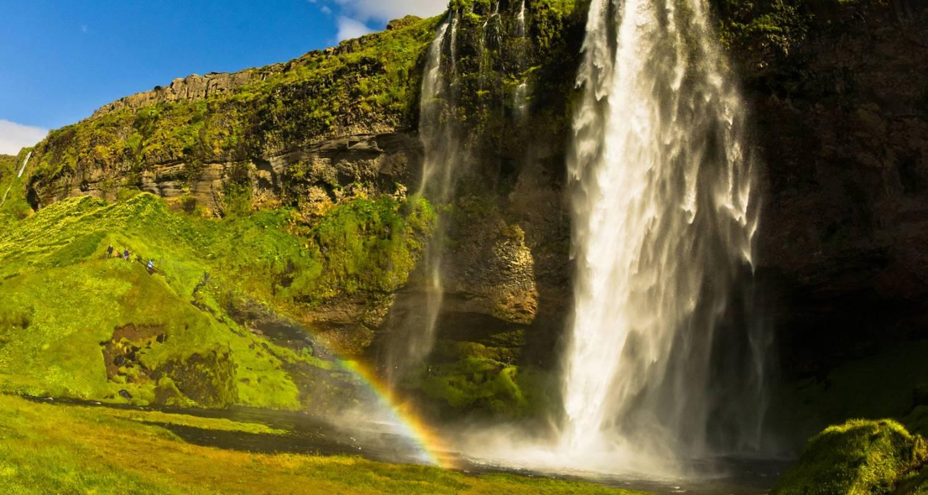



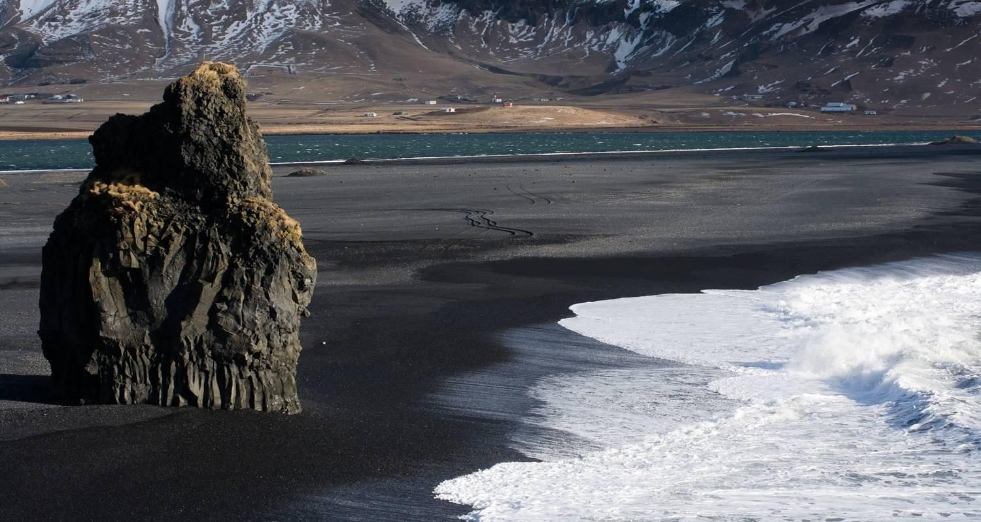

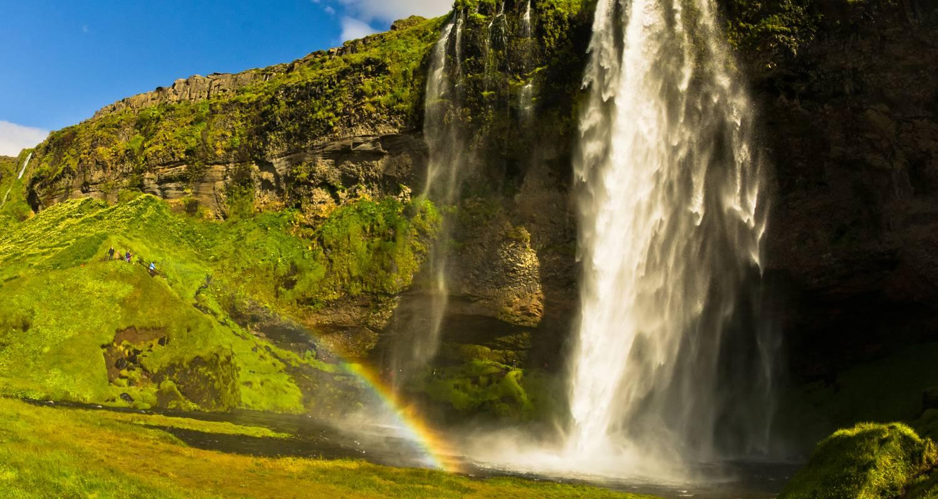



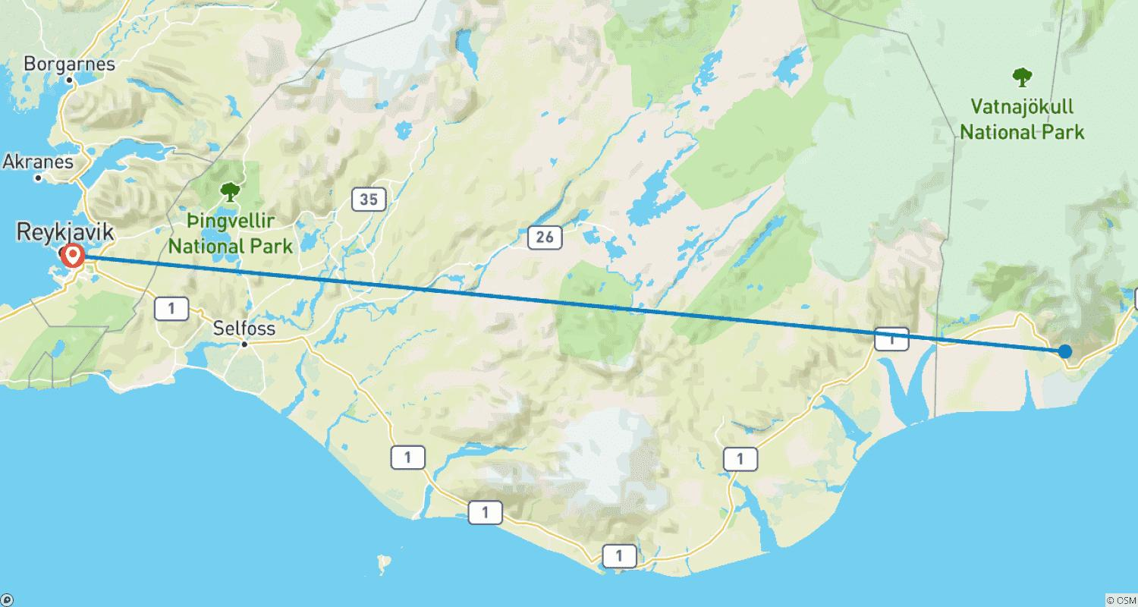

Tour ID: 234036  
Tour Name: Geysers, Glaciers, & Golden Circle - 3 days

Tour destinations: ['Reykjavik', 'Thingvellir National Park', 'Geysir', 'Gullfoss', 'Vik', 'Jokulsarlon', 'Skogafoss', 'Fjadrargljufur', 'Reynisfjara', 'Eyjafjallajokull']

Tour destinations images:

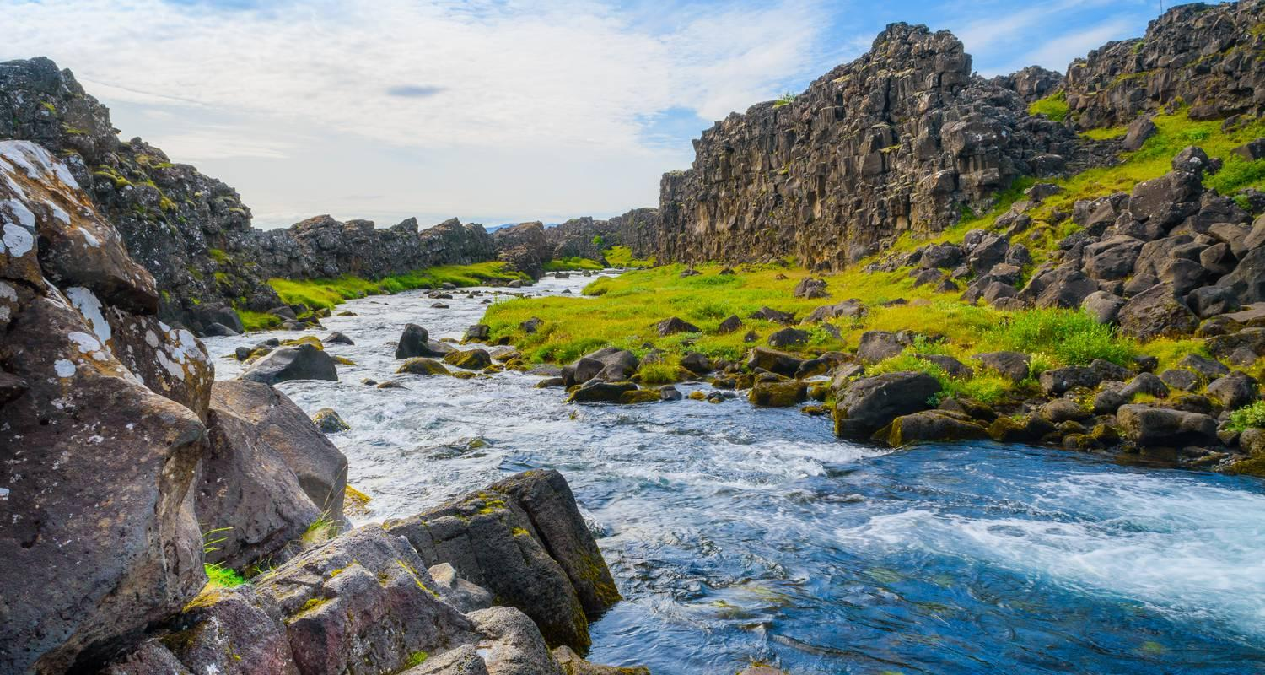

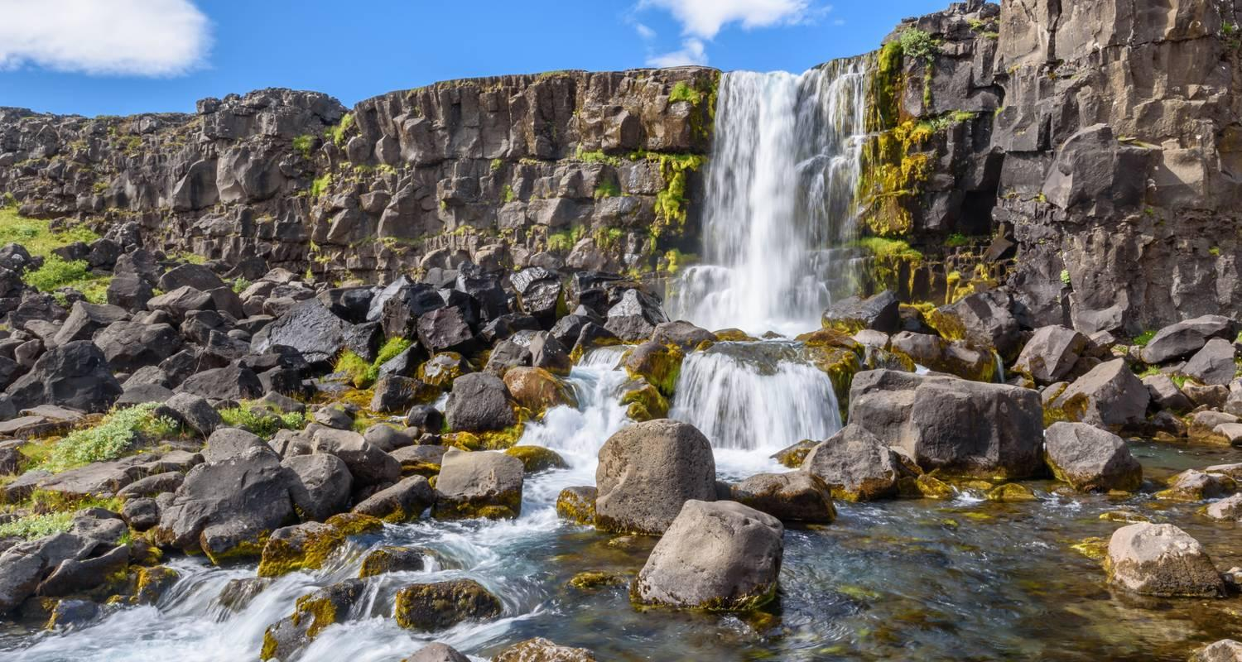

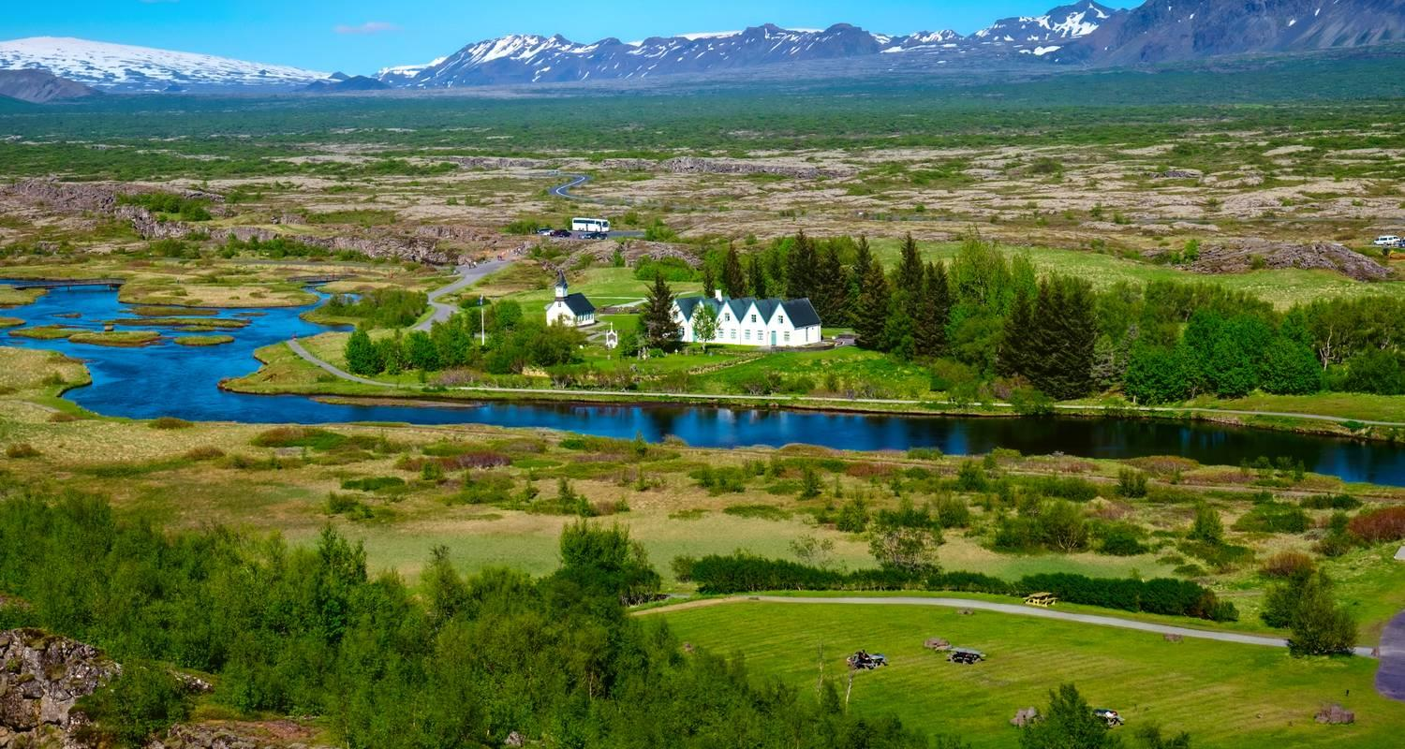

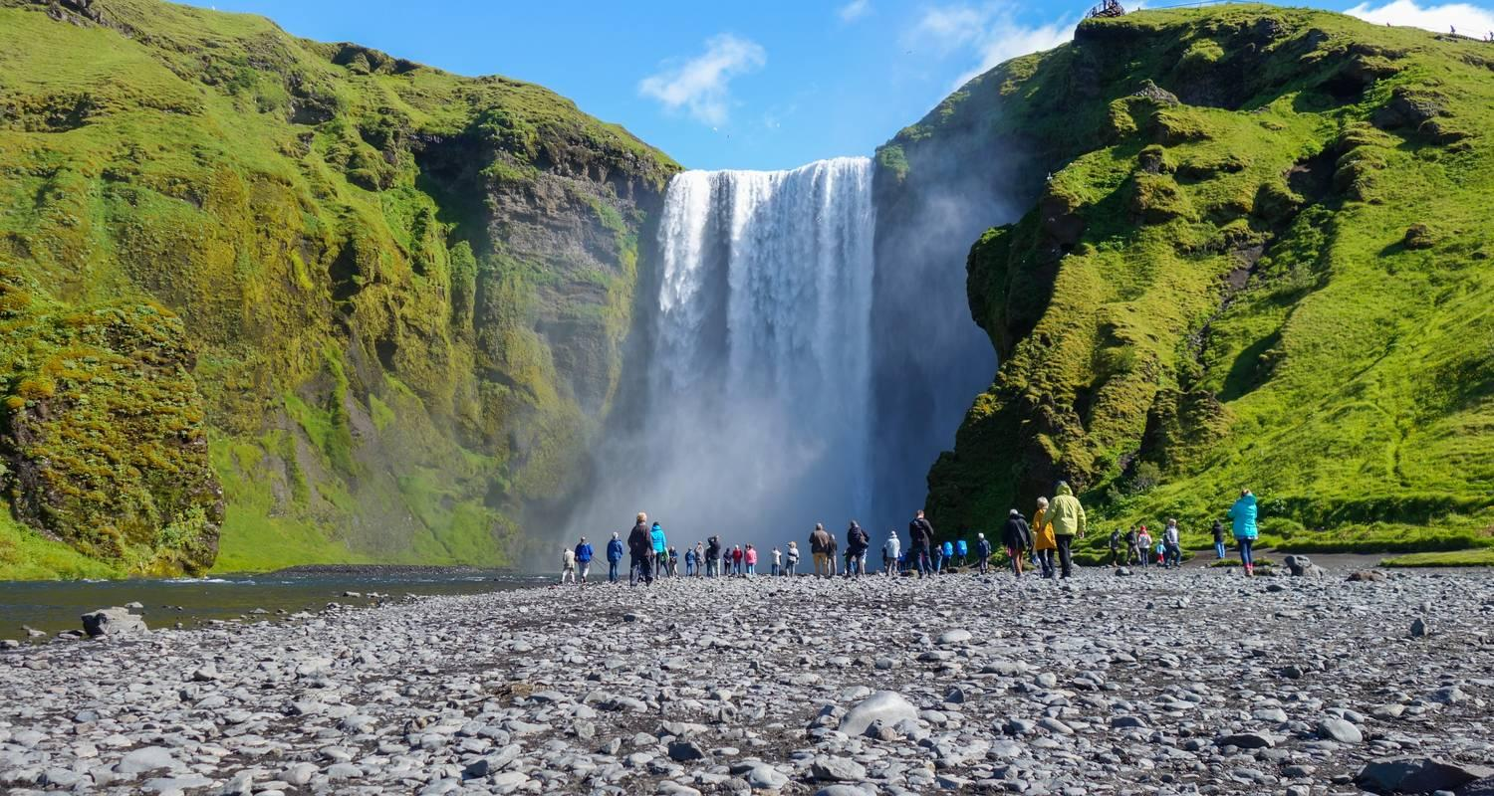

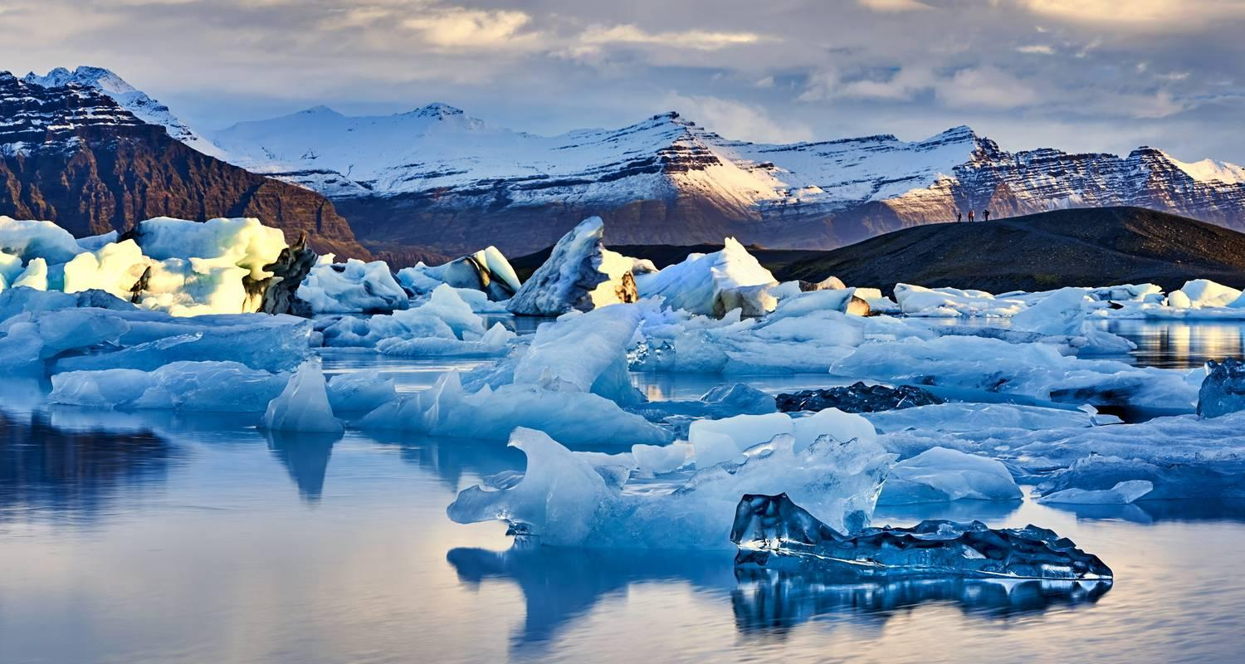

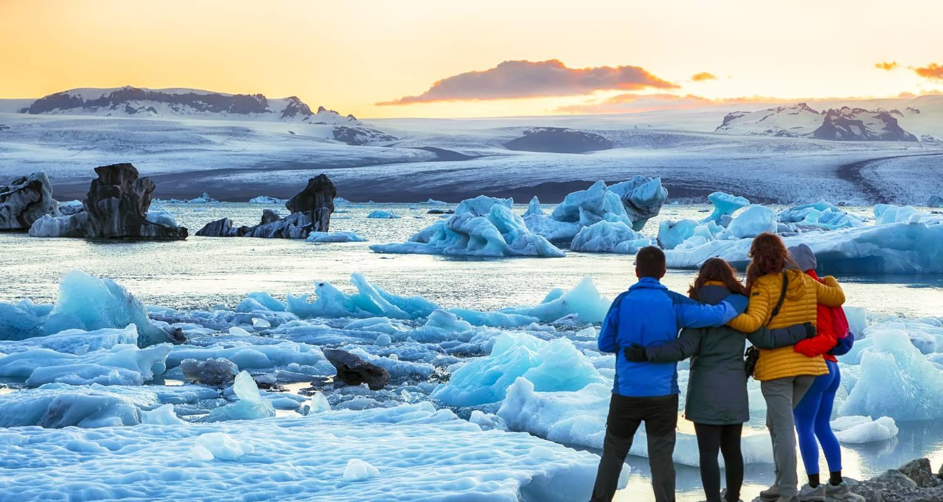



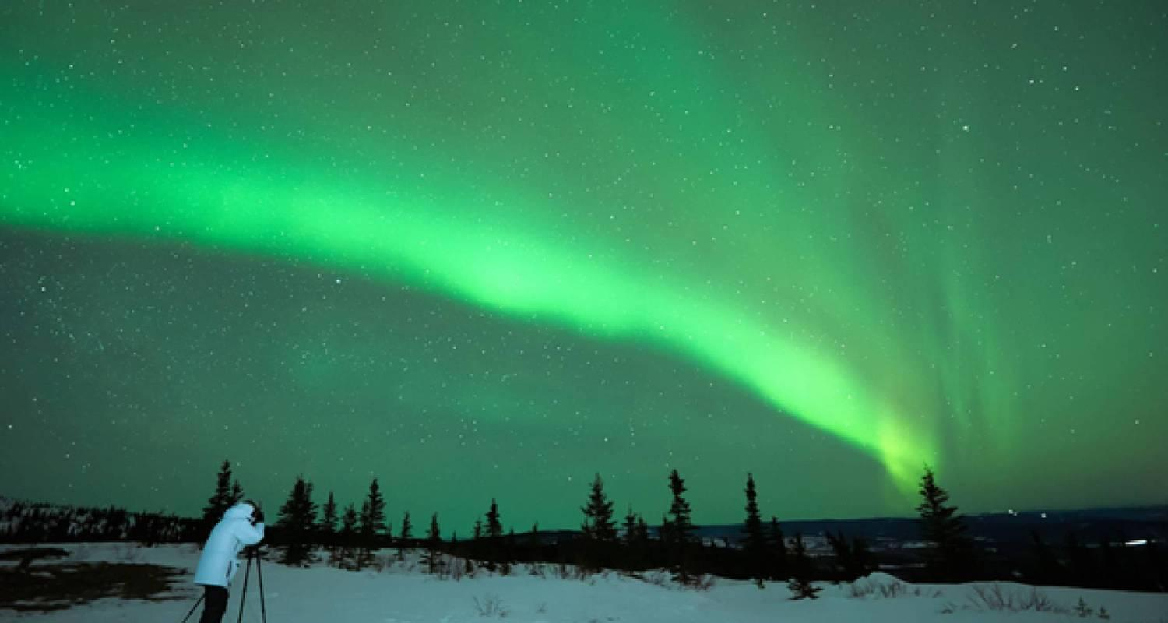

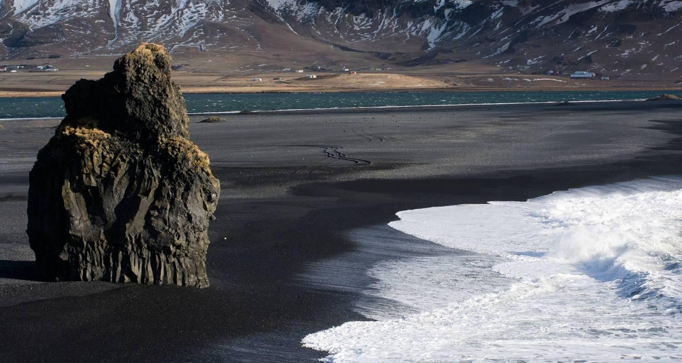

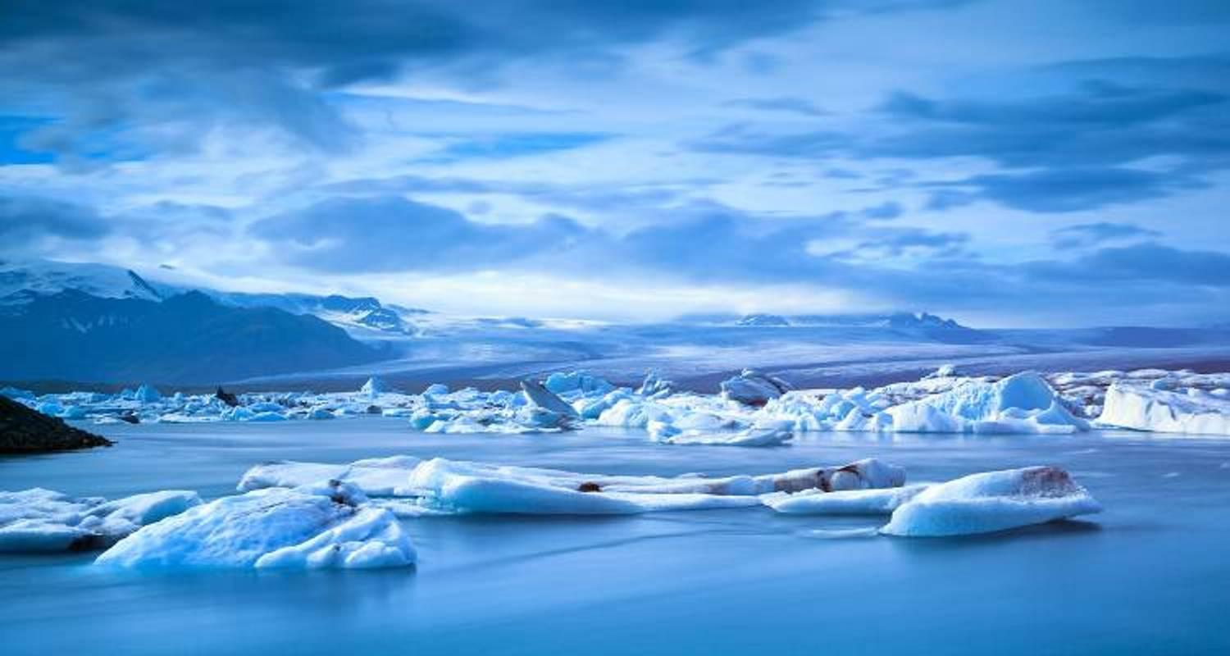

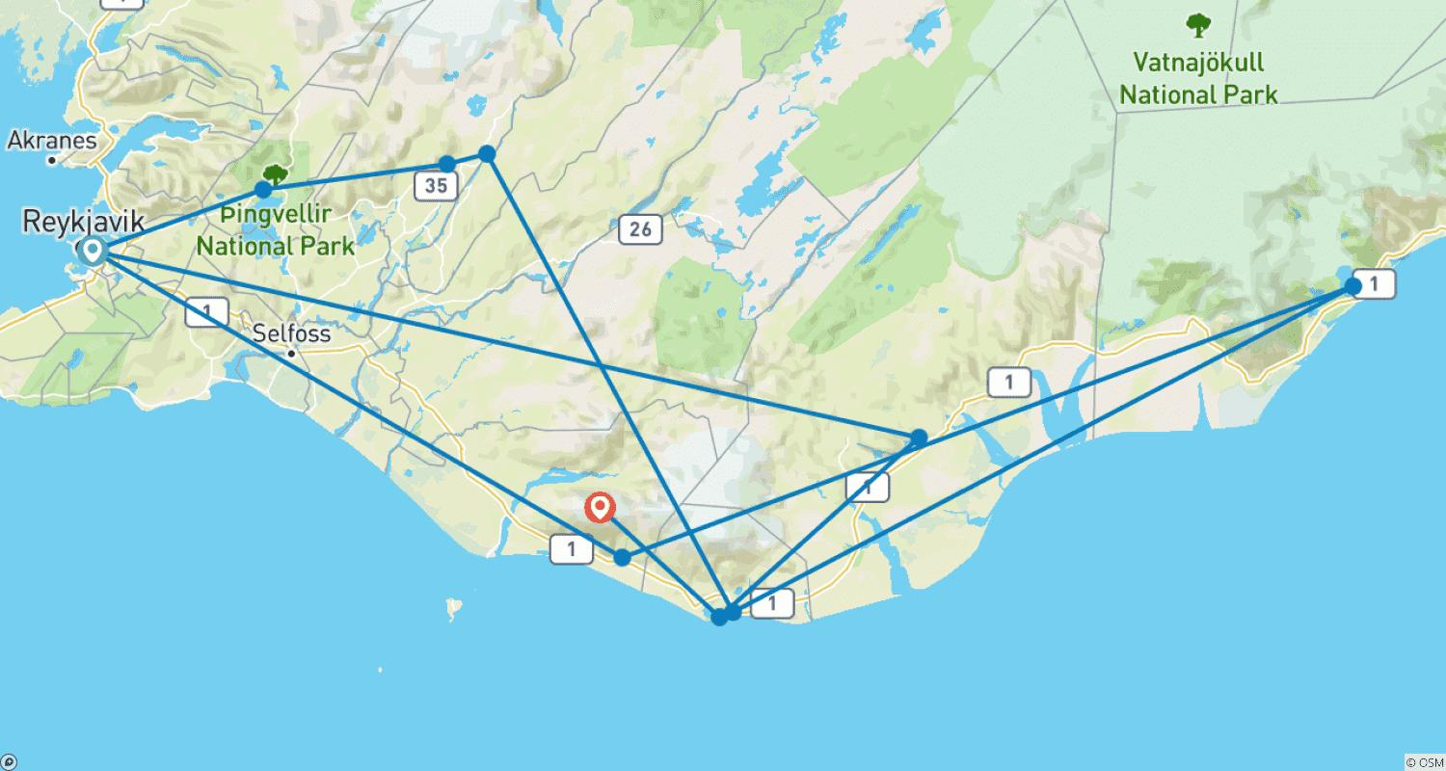

Tour ID: 236552  
Tour Name: Hiking Southern Iceland

Tour destinations: ['Reykjavik', 'Vik', 'Hof', 'Kirkjubaejarklaustur']

Tour destinations images:

